**Exercise 1: Control Structures**

**Scenario 1:** The bank wants to apply a discount to loan interest rates for customers above 60 years old.

* + **Question:** Write a PL/SQL block that loops through all customers, checks their age, and if they are above 60, apply a 1% discount to their current loan interest rates.

**Sql:**

USE bankdb;

DROP PROCEDURE IF EXISTS ApplySeniorDiscount;

DELIMITER //

CREATE PROCEDURE ApplySeniorDiscount()

BEGIN

DECLARE done INT DEFAULT FALSE;

DECLARE c_id INT;

DECLARE c_dob DATE;

DECLARE age INT;

DECLARE cur CURSOR FOR SELECT CustomerID, DOB FROM Customers;

DECLARE CONTINUE HANDLER FOR NOT FOUND SET done = TRUE;

OPEN cur;

read_loop: LOOP

FETCH cur INTO c_id, c_dob;

IF done THEN LEAVE read_loop; END IF;

SET age = TIMESTAMPDIFF(YEAR, c_dob, CURDATE());

IF age > 60 THEN

UPDATE Loans

SET InterestRate = InterestRate - 1

WHERE CustomerID = c_id;

END IF;

END LOOP;

CLOSE cur;

END;

//

DELIMITER ;

CALL ApplySeniorDiscount();

SELECT * FROM Loans;

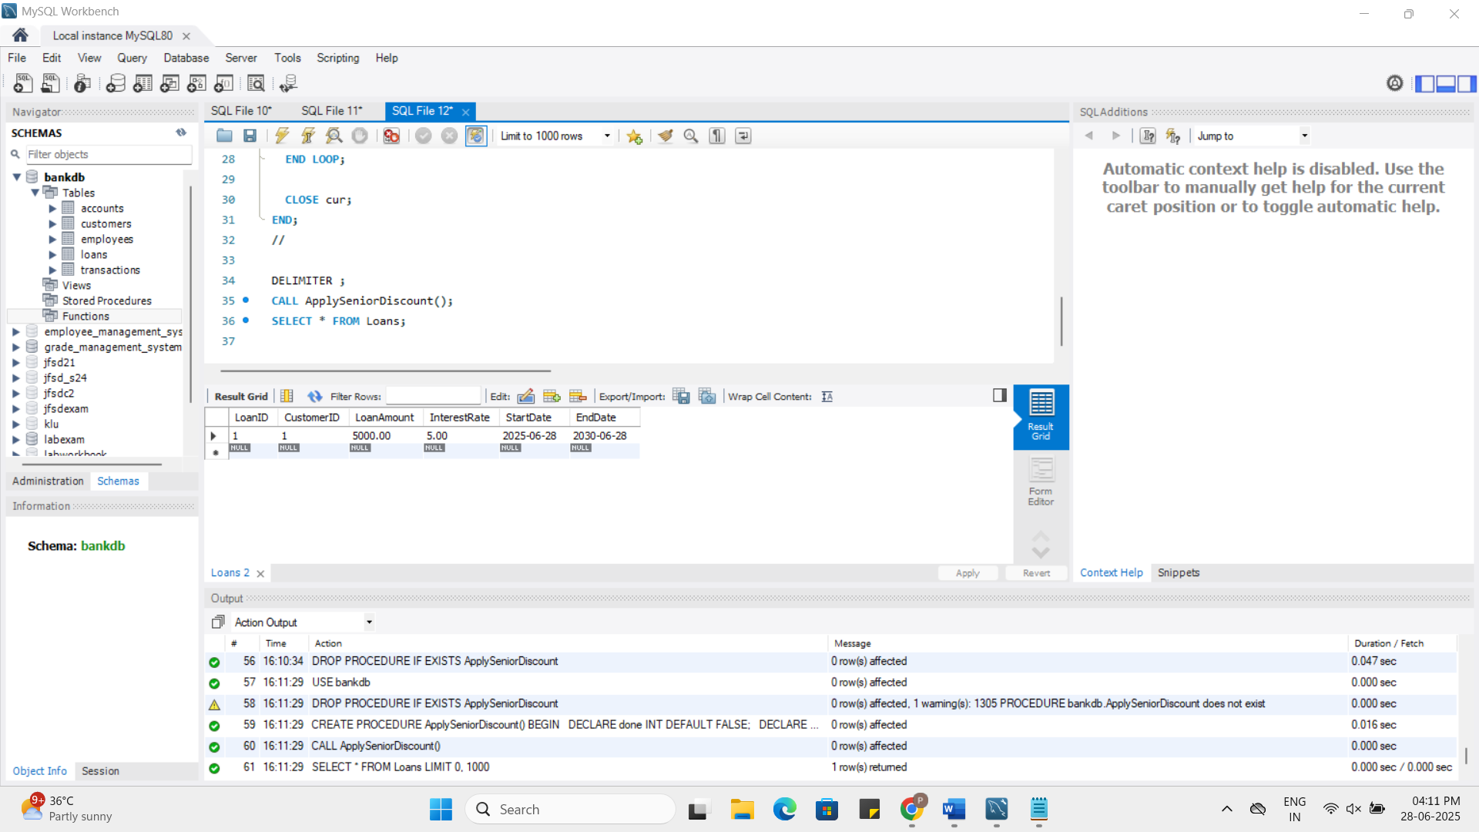

**Scenario 2:** A customer can be promoted to VIP status based on their balance.

* + **Question:** Write a PL/SQL block that iterates through all customers and sets a flag IsVIP to TRUE for those with a balance over $10,000.

**Sql:**  
USE bankdb;

ALTER TABLE Customers ADD COLUMN IsVIP BOOLEAN DEFAULT FALSE;

DELIMITER //

CREATE PROCEDURE PromoteVIPCustomers()

BEGIN

DECLARE done INT DEFAULT FALSE;

DECLARE c_id INT;

DECLARE c_bal DECIMAL(10,2);

DECLARE cur CURSOR FOR SELECT CustomerID, Balance FROM Customers;

DECLARE CONTINUE HANDLER FOR NOT FOUND SET done = TRUE;

OPEN cur;

vip_loop: LOOP

FETCH cur INTO c_id, c_bal;

IF done THEN LEAVE vip_loop; END IF;

IF c_bal > 10000 THEN

UPDATE Customers SET IsVIP = TRUE WHERE CustomerID = c_id;

END IF;

END LOOP;

CLOSE cur;

END;

//

DELIMITER ;

CALL PromoteVIPCustomers();

SELECT * FROM Customers;

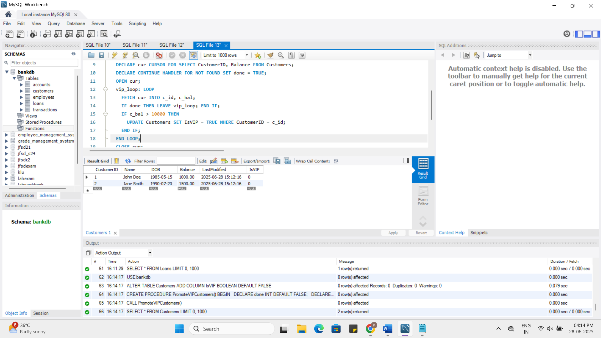

**Scenario 3:** The bank wants to send reminders to customers whose loans are due within the next 30 days.

* + **Question:** Write a PL/SQL block that fetches all loans due in the next 30 days and prints a reminder message for each customer.

**Sql:**

USE bankdb;

DELIMITER //

CREATE PROCEDURE SendLoanReminders()

BEGIN

DECLARE done INT DEFAULT FALSE;

DECLARE loan_id INT;

DECLARE cust_id INT;

DECLARE end_date DATE;

DECLARE cust_name VARCHAR(100);

DECLARE cur CURSOR FOR

SELECT LoanID, CustomerID, EndDate FROM Loans

WHERE EndDate BETWEEN CURDATE() AND DATE_ADD(CURDATE(), INTERVAL 30 DAY);

DECLARE CONTINUE HANDLER FOR NOT FOUND SET done = TRUE;

OPEN cur;

reminder_loop: LOOP

FETCH cur INTO loan_id, cust_id, end_date;

IF done THEN LEAVE reminder_loop; END IF;

SELECT Name INTO cust_name FROM Customers WHERE CustomerID = cust_id;

SELECT CONCAT('Reminder: Dear ', cust_name, ', your loan #', loan_id,

' is due on ', DATE_FORMAT(end_date, '%Y-%m-%d')) AS Reminder;

END LOOP;

CLOSE cur;

END;

//

DELIMITER ;SendLoanReminders

CALL SendLoanReminders();

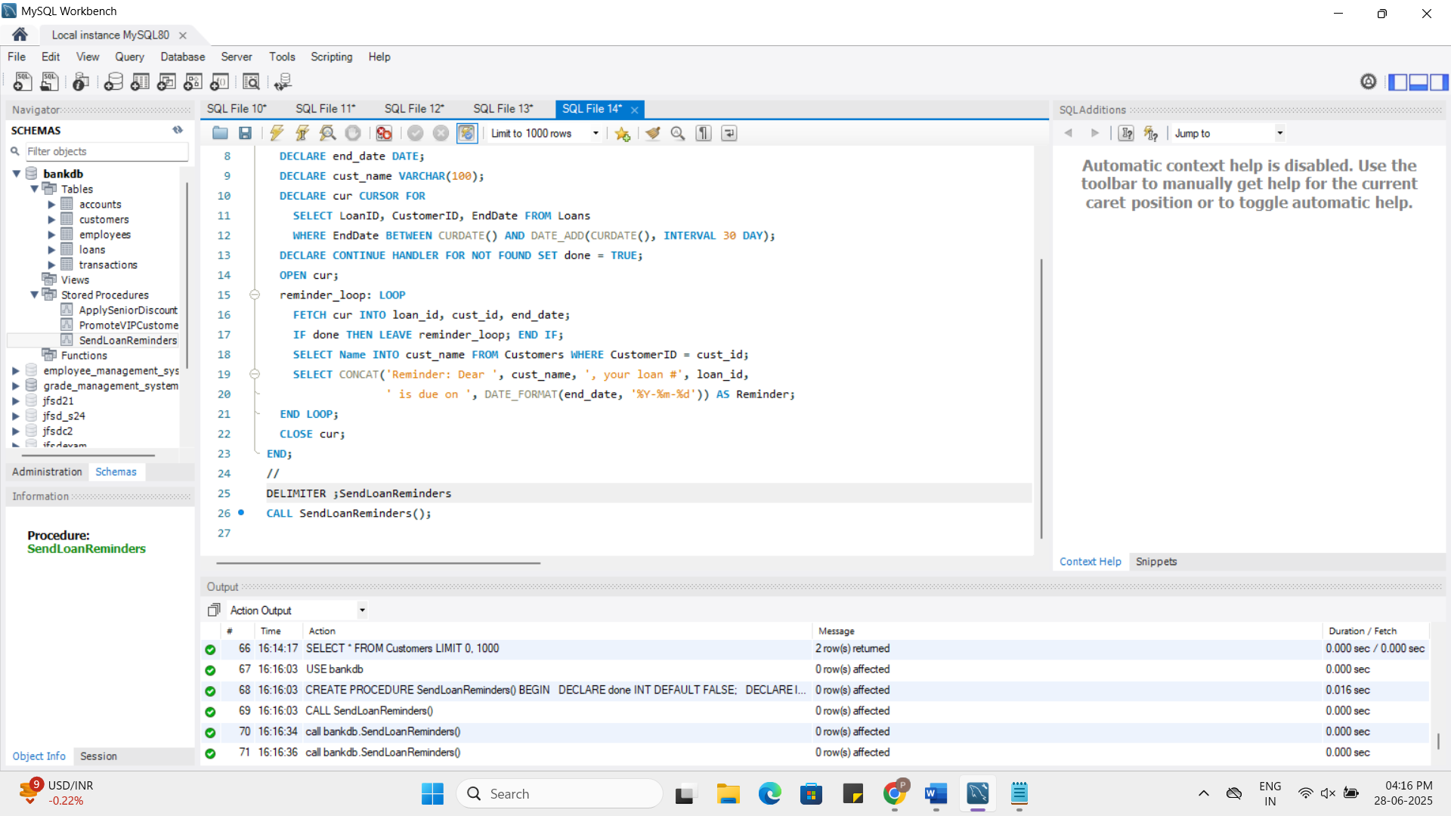

**Exercise 2: Error Handling**

**Creation of Erro Log table :**

USE bankdb;

CREATE TABLE ErrorLogs (

ErrorID INT AUTO_INCREMENT PRIMARY KEY,

ErrorMessage VARCHAR(255),

LogTime DATETIME DEFAULT NOW()

);

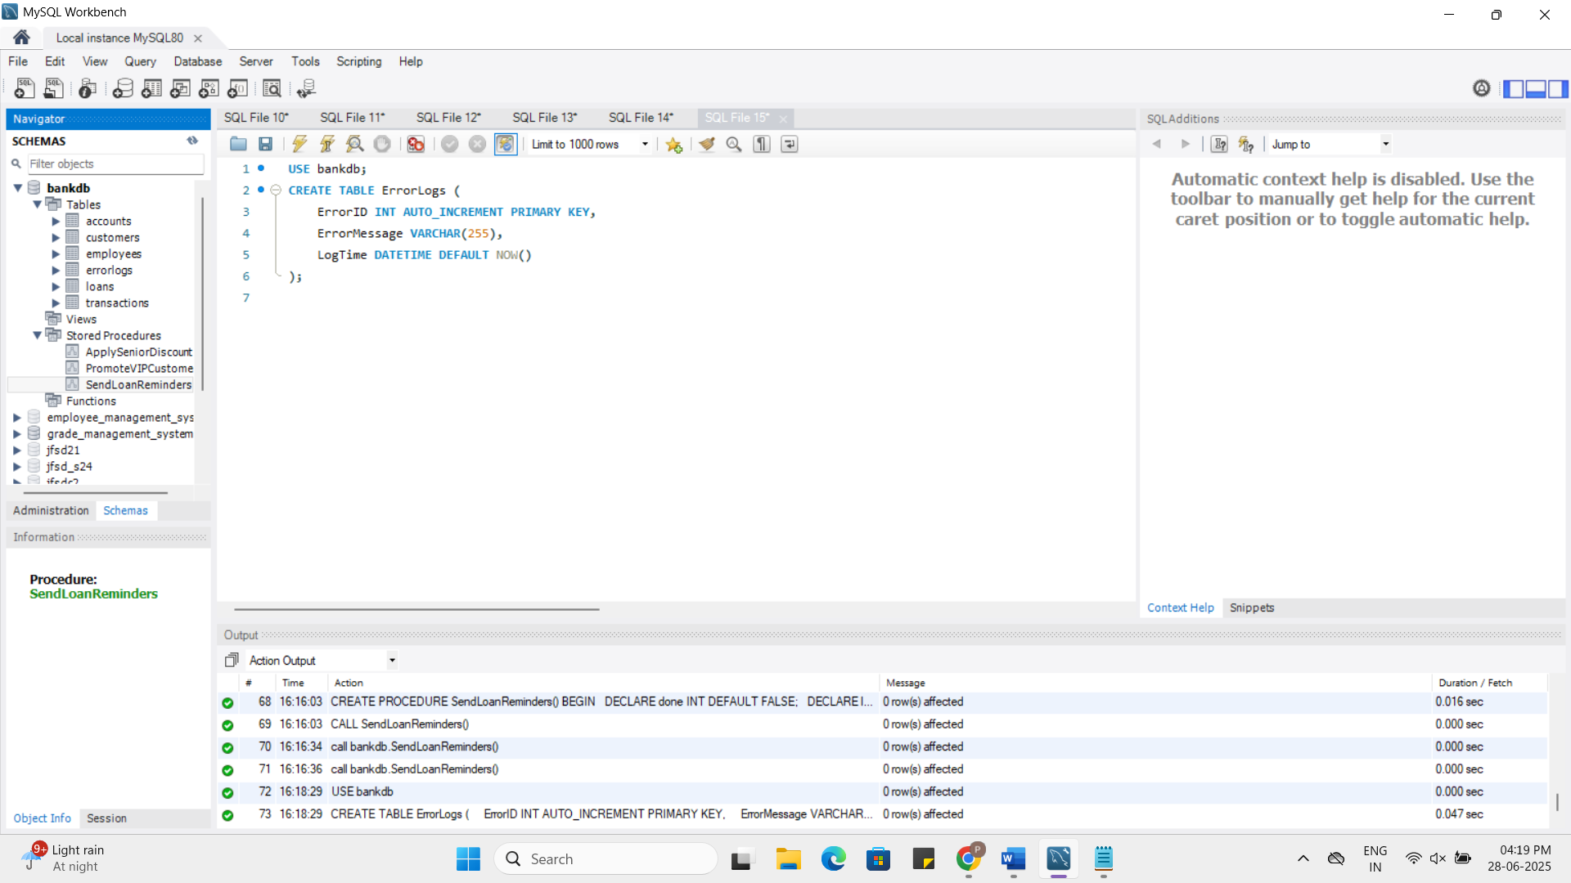

**Scenario 1:** Handle exceptions during fund transfers between accounts.

* + **Question:** Write a stored procedure **SafeTransferFunds** that transfers funds between two accounts. Ensure that if any error occurs (e.g., insufficient funds), an appropriate error message is logged and the transaction is rolled back.

**Sql:**

USE bankdb;

DROP PROCEDURE IF EXISTS SafeTransferFunds;

DELIMITER //

CREATE PROCEDURE SafeTransferFunds(

IN fromAccountID INT,

IN toAccountID INT,

IN amount DECIMAL(10,2)

)

BEGIN

DECLARE insufficient_funds CONDITION FOR SQLSTATE '45000';

DECLARE EXIT HANDLER FOR SQLEXCEPTION

BEGIN

ROLLBACK;

INSERT INTO ErrorLogs(ErrorMessage) VALUES('Error during fund transfer');

END;

START TRANSACTION;

IF (SELECT Balance FROM Accounts WHERE AccountID = fromAccountID) < amount THEN

SIGNAL SQLSTATE '45000' SET MESSAGE_TEXT = 'Insufficient funds';

END IF;

UPDATE Accounts SET Balance = Balance - amount WHERE AccountID = fromAccountID;

UPDATE Accounts SET Balance = Balance + amount WHERE AccountID = toAccountID;

COMMIT;

END;

//

DELIMITER ;

CALL SafeTransferFunds(1, 2, 200);

SELECT * FROM Accounts;

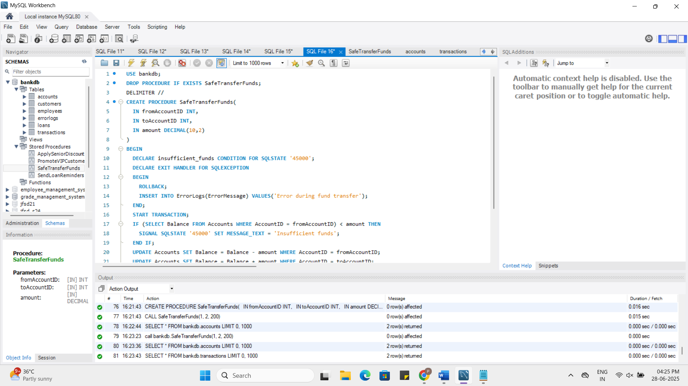

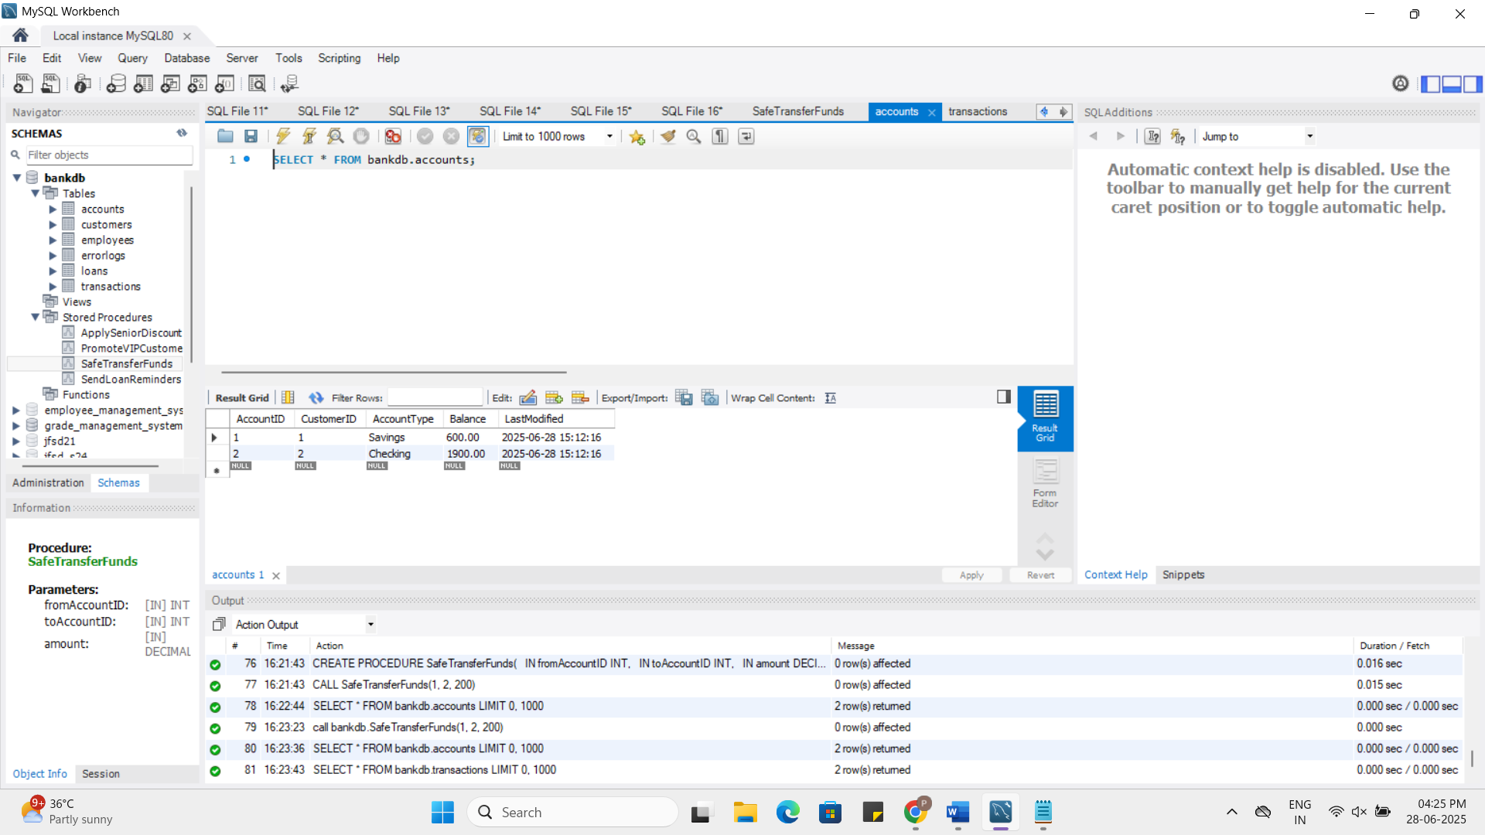

**Scenario 2:** Manage errors when updating employee salaries.

* + **Question:** Write a stored procedure **UpdateSalary** that increases the salary of an employee by a given percentage. If the employee ID does not exist, handle the exception and log an error message.

**Sql:**

USE bankdb;

DROP PROCEDURE IF EXISTS UpdateSalary;

DELIMITER //

CREATE PROCEDURE UpdateSalary(

IN empID INT,

IN percent DECIMAL(5,2)

)

BEGIN

DECLARE EXIT HANDLER FOR SQLEXCEPTION

BEGIN

INSERT INTO ErrorLogs(ErrorMessage) VALUES('Error updating salary - check employee ID');

END;

UPDATE Employees

SET Salary = Salary + (Salary * percent / 100)

WHERE EmployeeID = empID;

IF ROW_COUNT() = 0 THEN

SIGNAL SQLSTATE '45000' SET MESSAGE_TEXT = 'Employee ID not found';

END IF;

END;

//

DELIMITER ;

CALL UpdateSalary(1, 10);

SELECT * FROM Employees;

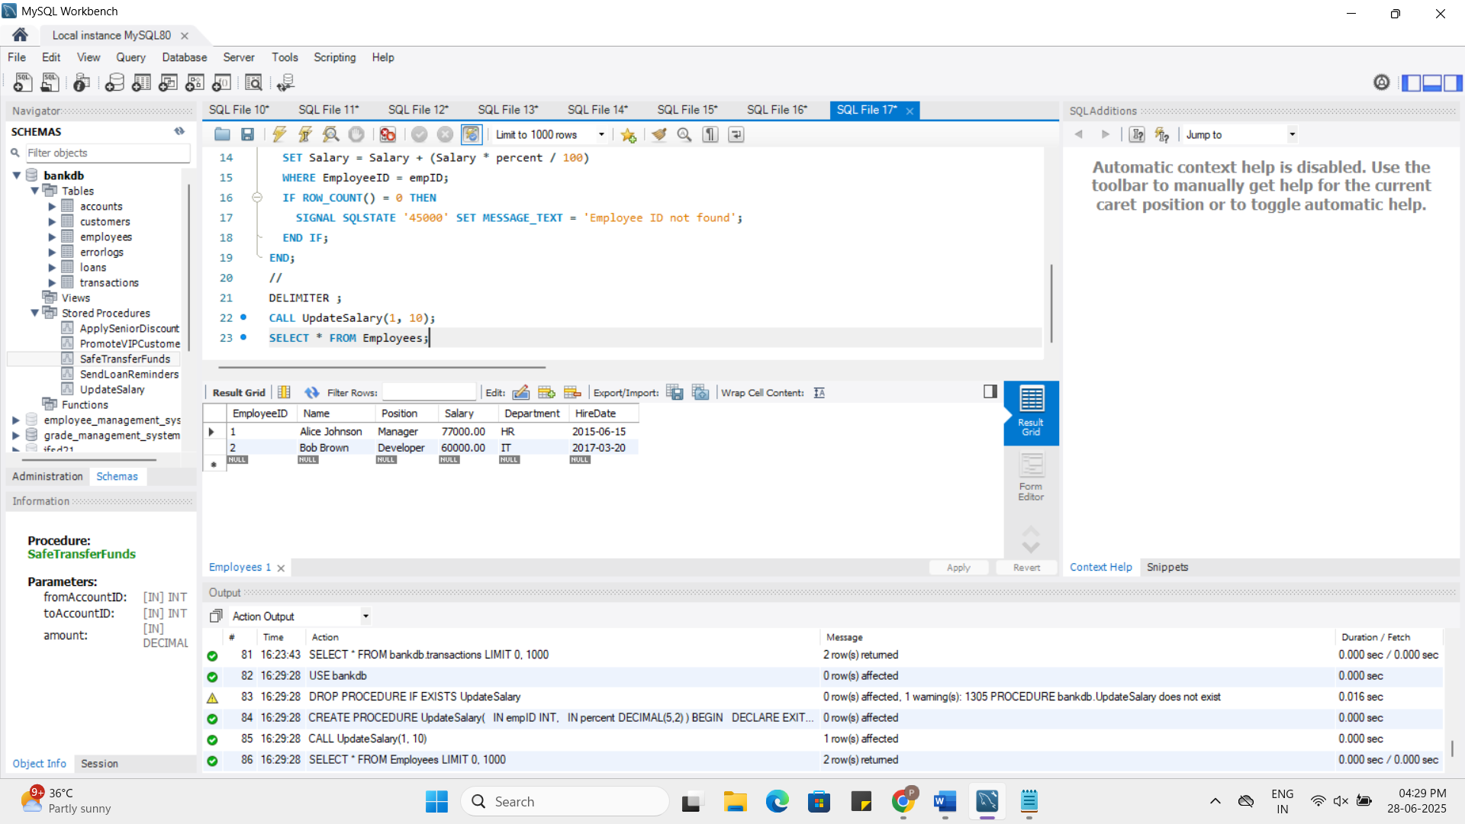

**Scenario 3:** Ensure data integrity when adding a new customer.

* + **Question:** Write a stored procedure **AddNewCustomer** that inserts a new customer into the Customers table. If a customer with the same ID already exists, handle the exception by logging an error and preventing the insertion.

**Sql:**

USE bankdb;

DROP PROCEDURE IF EXISTS AddNewCustomer;

DELIMITER //

CREATE PROCEDURE AddNewCustomer(

IN p_CustomerID INT,

IN p_Name VARCHAR(100),

IN p_DOB DATE,

IN p_Balance DECIMAL(10,2)

)

BEGIN

DECLARE EXIT HANDLER FOR SQLEXCEPTION

BEGIN

INSERT INTO ErrorLogs(ErrorMessage) VALUES('Error adding new customer - Duplicate ID');

END;

INSERT INTO Customers(CustomerID, Name, DOB, Balance, LastModified)

VALUES (p_CustomerID, p_Name, p_DOB, p_Balance, NOW());

END;

//

DELIMITER ;

CALL AddNewCustomer(3, 'Ravi Kumar', '1980-02-01', 2000);

SELECT * FROM Customers ;

SELECT * FROM ErrorLogs ORDER BY LogTime DESC;

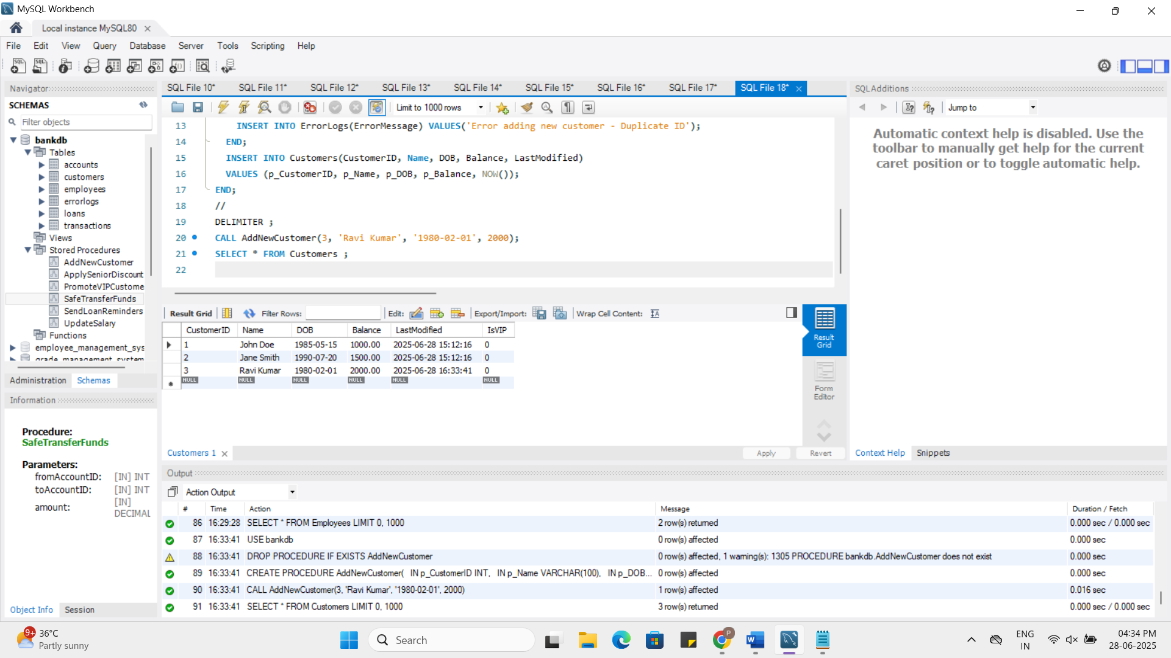

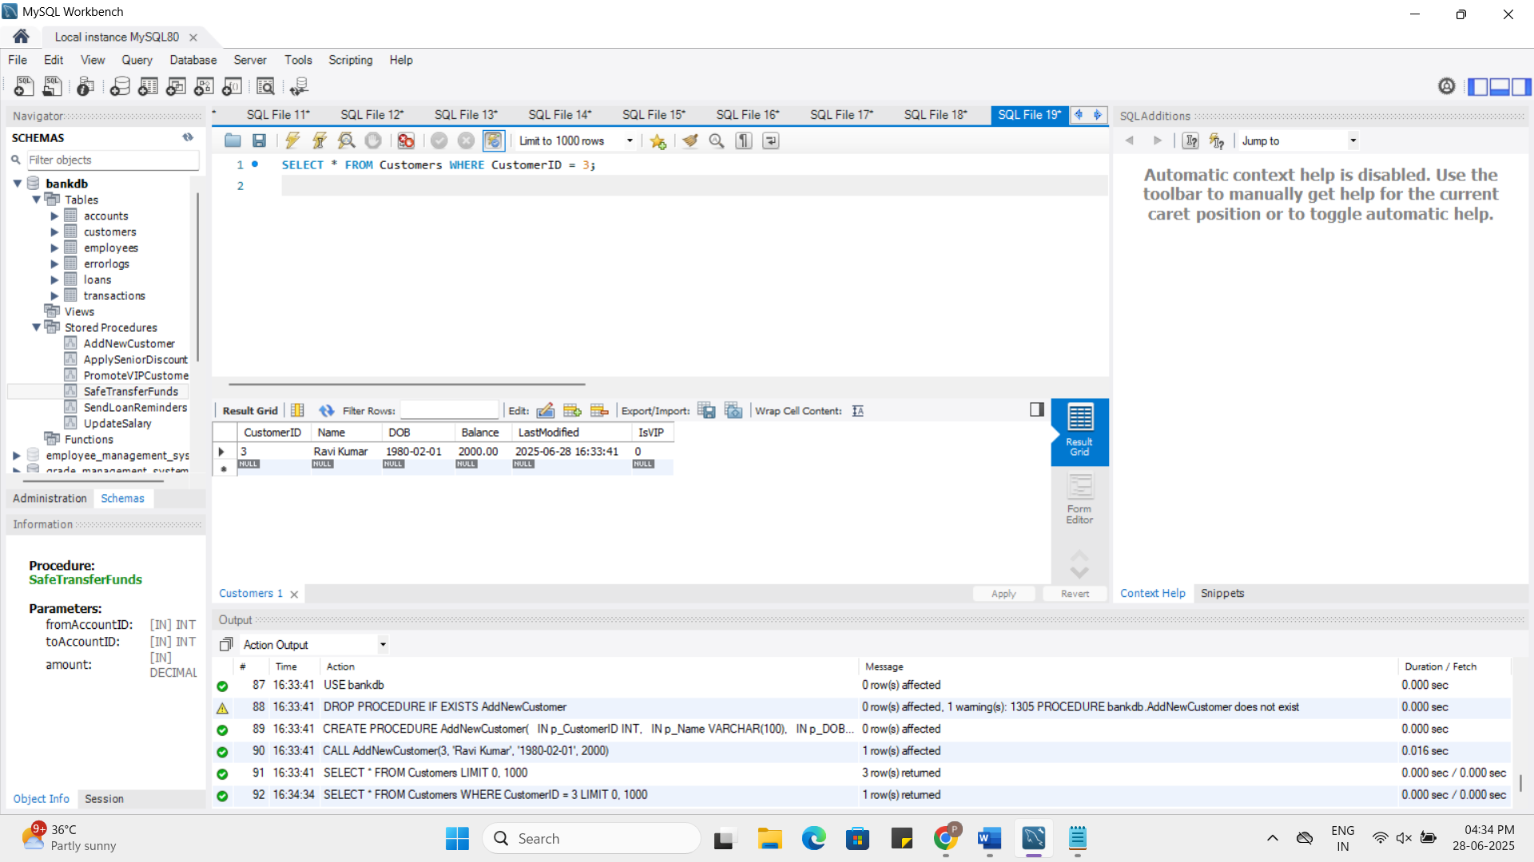

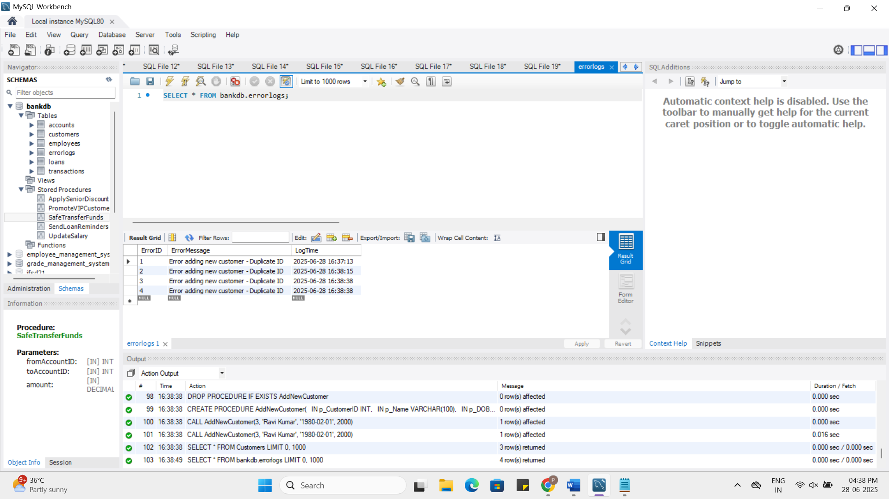

**Exercise 3: Stored Procedures**

**Scenario 1:** The bank needs to process monthly interest for all savings accounts.

* + **Question:** Write a stored procedure **ProcessMonthlyInterest** that calculates and updates the balance of all savings accounts by applying an interest rate of 1% to the current balance.

**Sql:**

DROP PROCEDURE IF EXISTS ProcessMonthlyInterest;

DELIMITER //

CREATE PROCEDURE ProcessMonthlyInterest()

BEGIN

UPDATE Accounts

SET Balance = Balance + (Balance * 0.01)

WHERE AccountType = 'Savings' AND AccountID IS NOT NULL;

END;

//

DELIMITER ;

CALL ProcessMonthlyInterest();

SELECT * FROM Accounts WHERE AccountType = 'Savings';

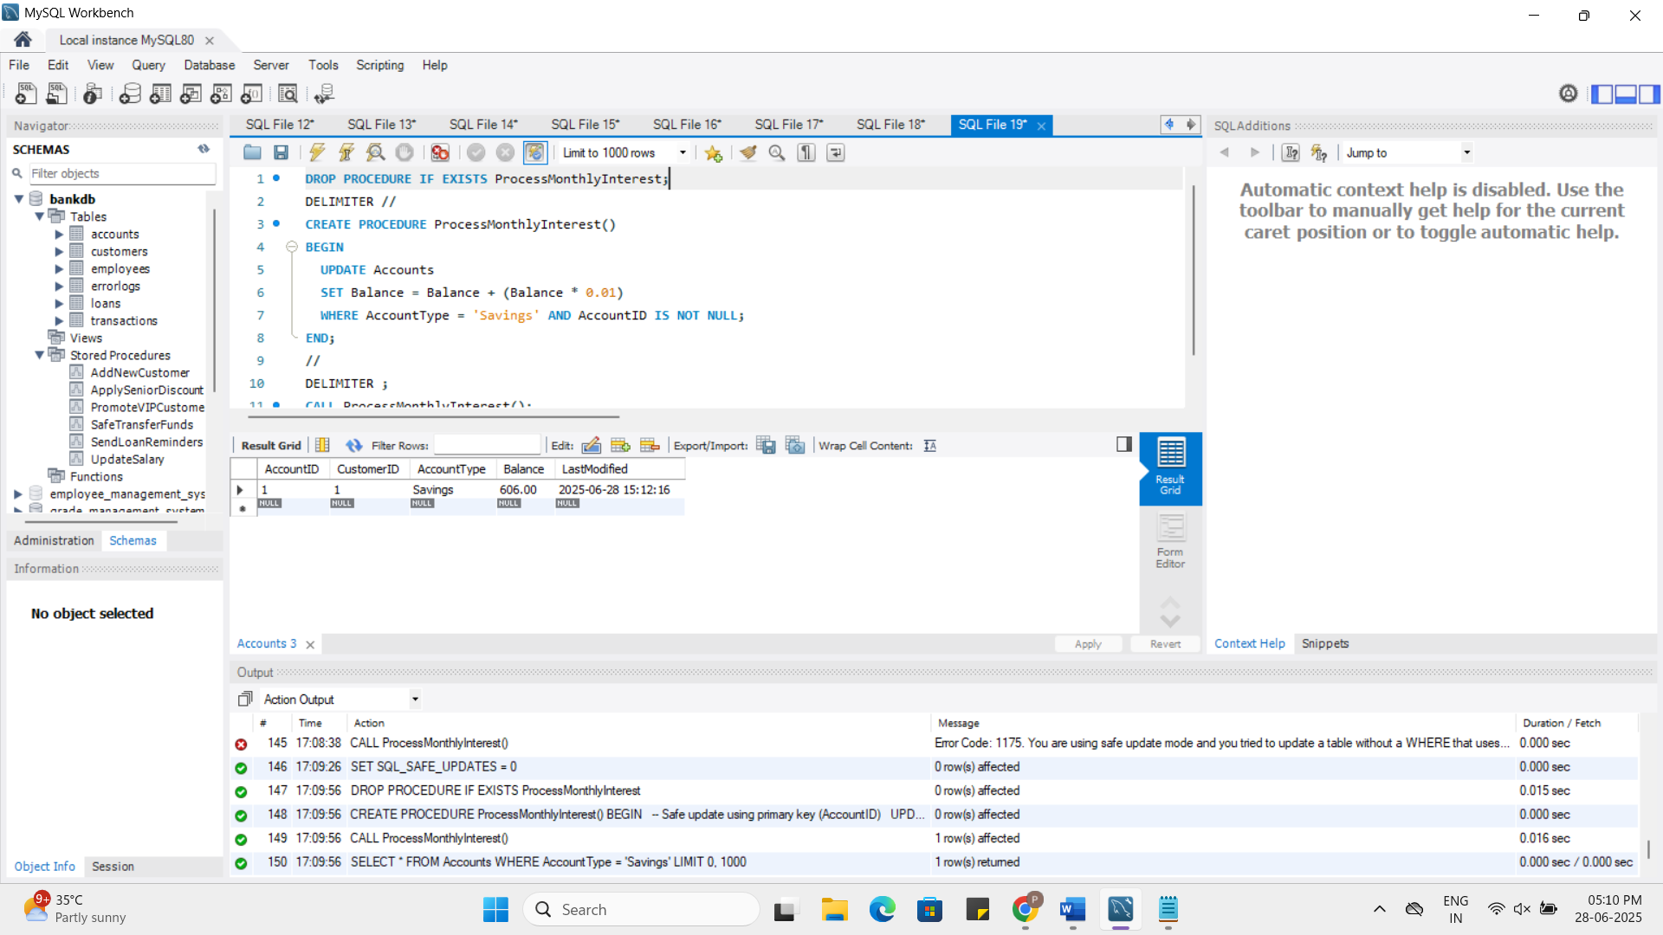

**Scenario 2:** The bank wants to implement a bonus scheme for employees based on their performance.

* + **Question:** Write a stored procedure **UpdateEmployeeBonus** that updates the salary of employees in a given department by adding a bonus percentage passed as a parameter.

**Sql:**

USE bankdb;

DROP PROCEDURE IF EXISTS UpdateEmployeeBonus;

DELIMITER //

CREATE PROCEDURE UpdateEmployeeBonus(

IN deptName VARCHAR(50),

IN bonusPercent DECIMAL(5,2)

)

BEGIN

UPDATE Employees

SET Salary = Salary + (Salary * bonusPercent / 100)

WHERE Department = deptName AND EmployeeID IS NOT NULL;

END;

//

DELIMITER ;

CALL UpdateEmployeeBonus('IT', 10);

SELECT * FROM Employees WHERE Department = 'IT';

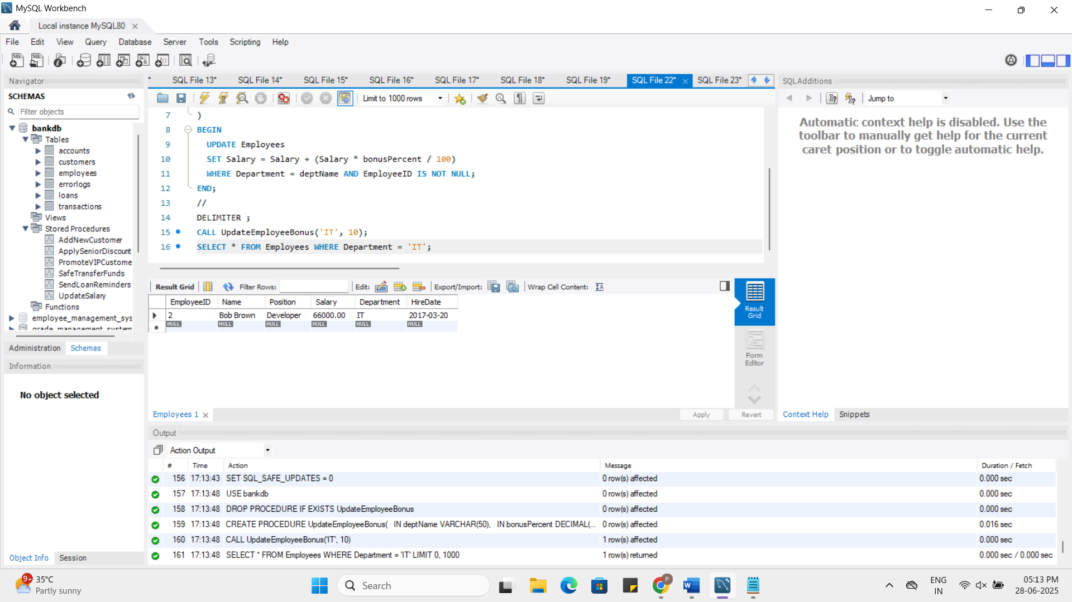

**Scenario 3:** Customers should be able to transfer funds between their accounts.

* + **Question:** Write a stored procedure **TransferFunds** that transfers a specified amount from one account to another, checking that the source account has sufficient balance before making the transfer.

**Sql:**

DROP PROCEDURE IF EXISTS TransferFunds;

DELIMITER //

CREATE PROCEDURE TransferFunds(

IN fromAccount INT,

IN toAccount INT,

IN amount DECIMAL(10,2)

)

BEGIN

DECLARE fromBalance DECIMAL(10,2);

SELECT Balance INTO fromBalance FROM Accounts WHERE AccountID = fromAccount;

IF fromBalance >= amount THEN

START TRANSACTION;

UPDATE Accounts SET Balance = Balance - amount WHERE AccountID = fromAccount;

UPDATE Accounts SET Balance = Balance + amount WHERE AccountID = toAccount;

COMMIT;

ELSE

SIGNAL SQLSTATE '45000'

SET MESSAGE_TEXT = 'Insufficient funds to complete transfer';

END IF;

END;

//

DELIMITER ;

CALL TransferFunds(1, 2, 200);

SELECT * FROM Accounts WHERE AccountID IN (1, 2);

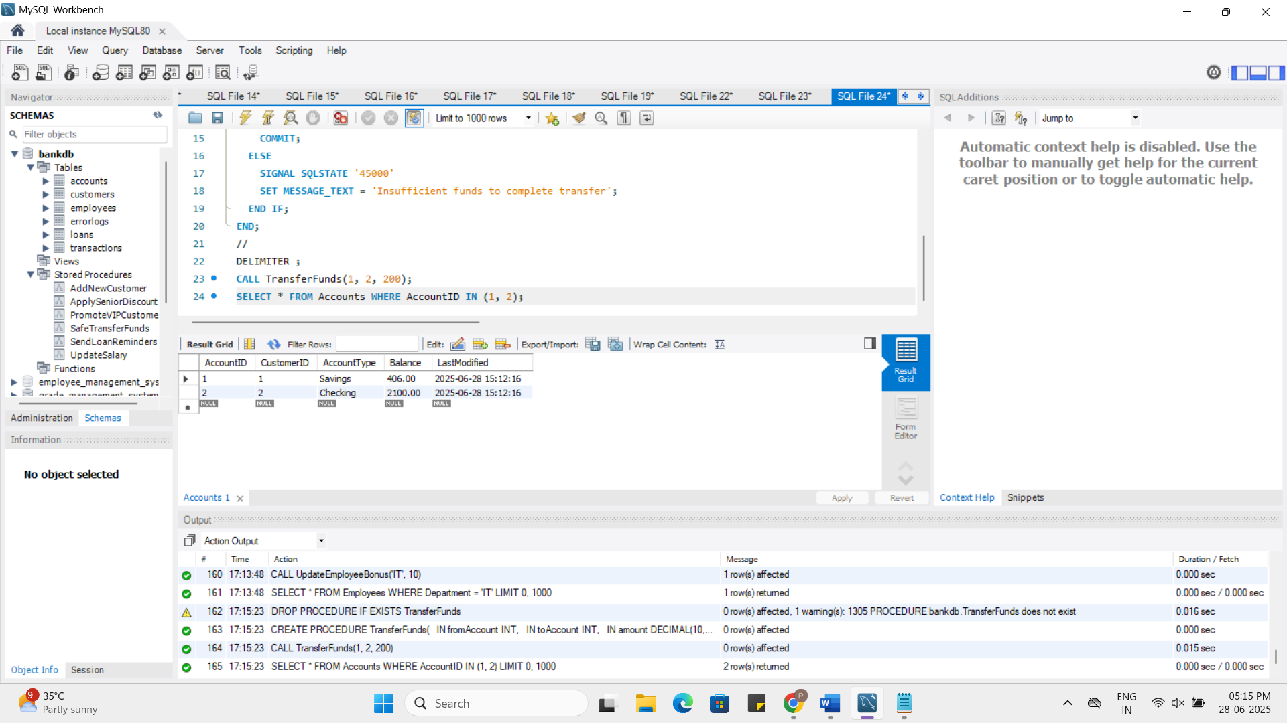

**Exercise 4: Functions**

**Scenario 1:** Calculate the age of customers for eligibility checks.

* + **Question:** Write a function CalculateAge that takes a customer's date of birth as input and returns their age in years.

**Sql:**

DROP FUNCTION IF EXISTS CalculateAge;

DELIMITER //

CREATE FUNCTION CalculateAge(dob DATE)

RETURNS INT

DETERMINISTIC

BEGIN

DECLARE age INT;

SET age = TIMESTAMPDIFF(YEAR, dob, CURDATE());

RETURN age;

END;

//

DELIMITER ;

SELECT Name, DOB, CalculateAge(DOB) AS Age FROM Customers;

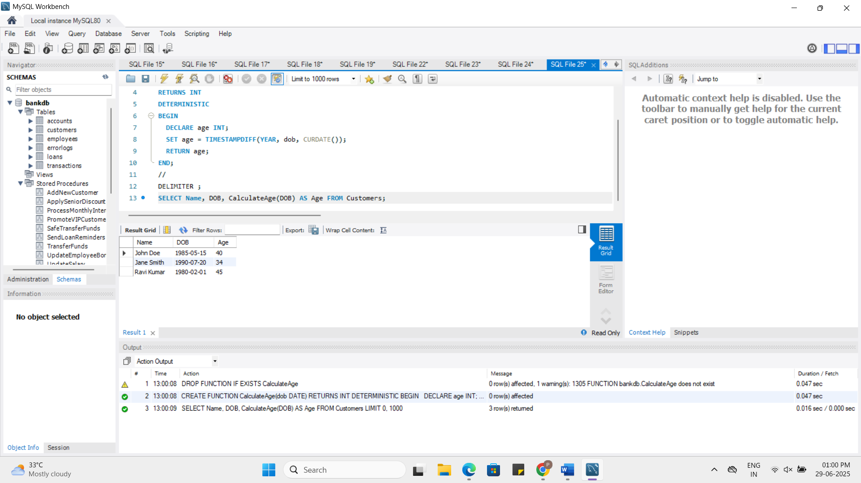

**Scenario 2:** The bank needs to compute the monthly installment for a loan.

* + **Question:** Write a function **CalculateMonthlyInstallment** that takes the loan amount, interest rate, and loan duration in years as input and returns the monthly installment amount.

**Sql:**

DROP FUNCTION IF EXISTS CalculateMonthlyInstallment;

DELIMITER //

CREATE FUNCTION CalculateMonthlyInstallment(

loanAmount DECIMAL(10,2),

annualRate DECIMAL(5,2),

years INT

)

RETURNS DECIMAL(10,2)

DETERMINISTIC

BEGIN

DECLARE monthlyRate DECIMAL(10,4);

DECLARE months INT;

DECLARE emi DECIMAL(10,2);

SET monthlyRate = annualRate / 12 / 100;

SET months = years * 12;

SET emi = (loanAmount * monthlyRate * POW(1 + monthlyRate, months)) /

(POW(1 + monthlyRate, months) - 1);

RETURN emi;

END;

//

DELIMITER ;

SELECT CalculateMonthlyInstallment(50000, 5, 5) AS MonthlyInstallment;

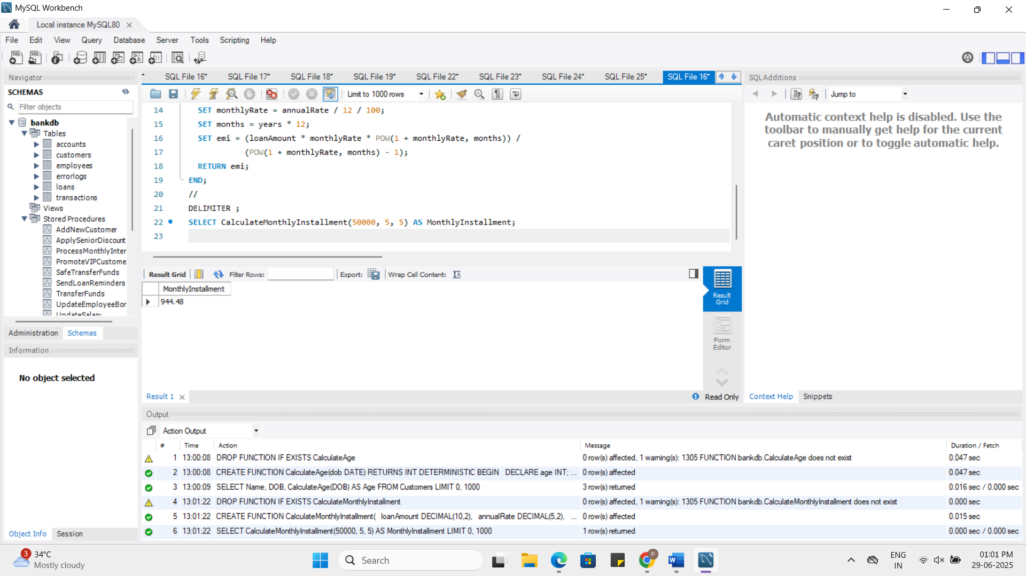

**Scenario 3:** Check if a customer has sufficient balance before making a transaction.

* + **Question:** Write a function **HasSufficientBalance** that takes an account ID and an amount as input and returns a boolean indicating whether the account has at least the specified amount.

**Sql:**

DROP FUNCTION IF EXISTS HasSufficientBalance;

DELIMITER //

CREATE FUNCTION HasSufficientBalance(

accID INT,

amt DECIMAL(10,2)

)

RETURNS BOOLEAN

DETERMINISTIC

BEGIN

DECLARE accBalance DECIMAL(10,2);

SELECT Balance INTO accBalance FROM Accounts WHERE AccountID = accID;

RETURN accBalance >= amt;

END;

//

DELIMITER ;

SELECT HasSufficientBalance(1, 500) AS IsEnoughBalance;

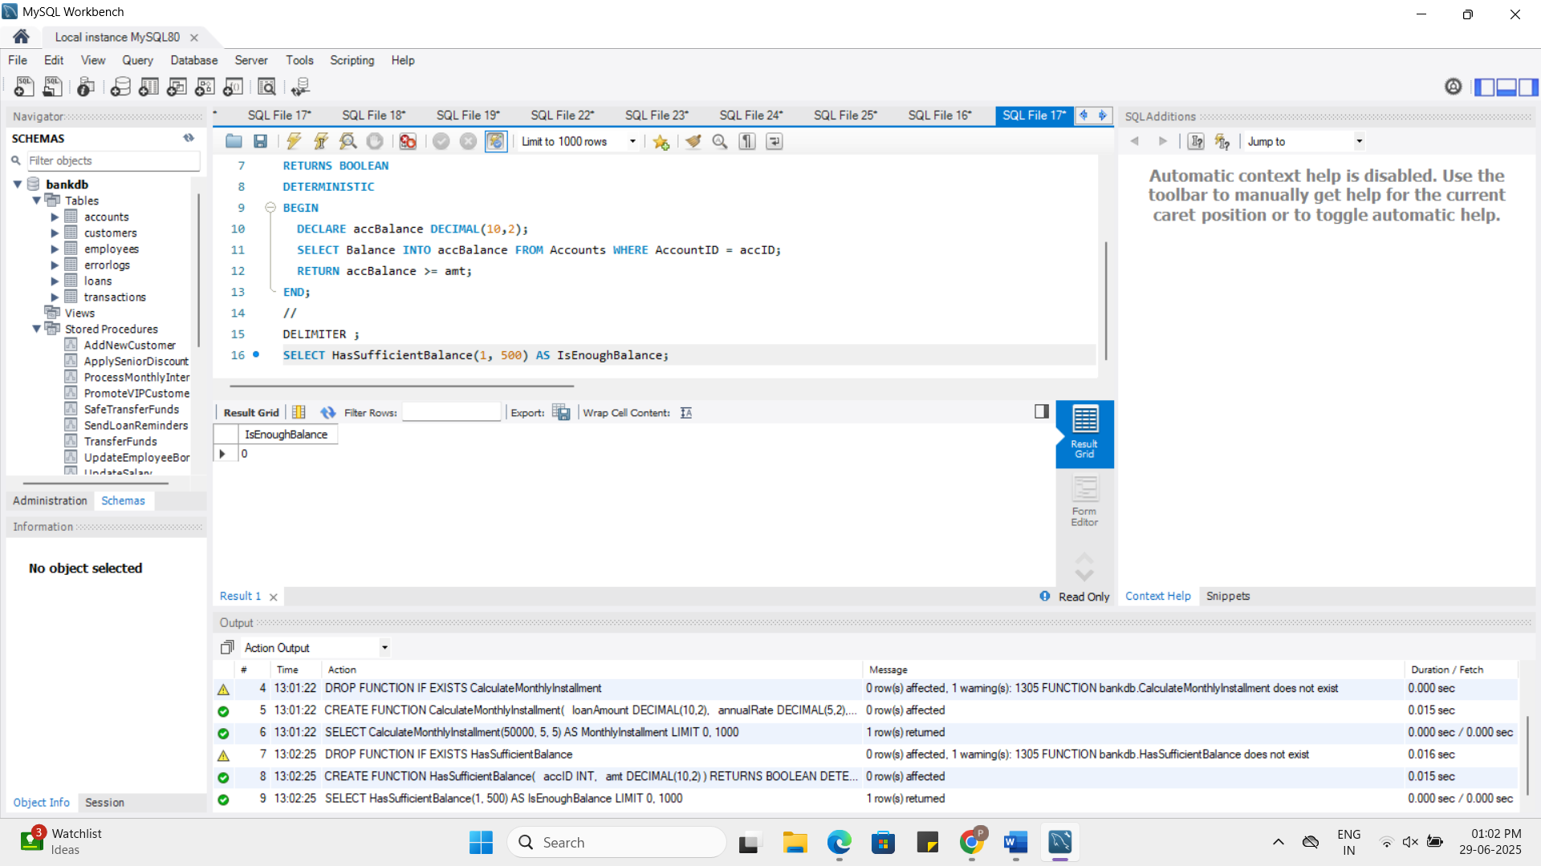

**Exercise 5: Triggers**

**Scenario 1:** Automatically update the last modified date when a customer's record is updated.

* + **Question:** Write a trigger **UpdateCustomerLastModified** that updates the LastModified column of the Customers table to the current date whenever a customer's record is updated.

**Sql:**

DROP TRIGGER IF EXISTS UpdateCustomerLastModified;

DELIMITER //

CREATE TRIGGER UpdateCustomerLastModified

BEFORE UPDATE ON Customers

FOR EACH ROW

BEGIN

SET NEW.LastModified = NOW();

END;

//

DELIMITER ;

UPDATE Customers SET Balance = Balance + 100 WHERE CustomerID = 1;

SELECT * FROM Customers WHERE CustomerID = 1;

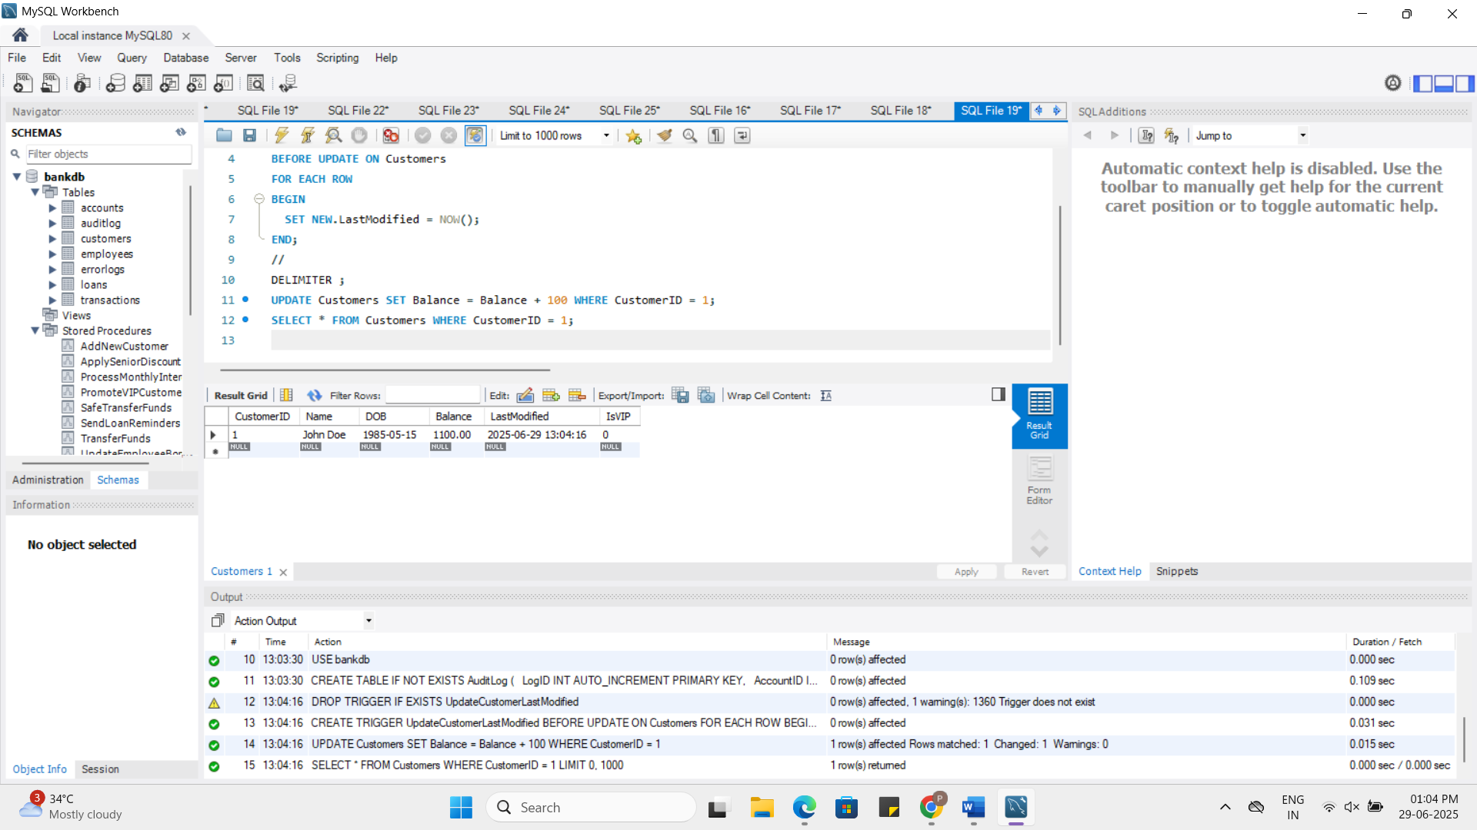

**Scenario 2:** Maintain an audit log for all transactions.

* + **Question:** Write a trigger **LogTransaction** that inserts a record into an AuditLog table whenever a transaction is inserted into the Transactions table.

**Sql:**

DROP TRIGGER IF EXISTS LogTransaction;

DELIMITER //

CREATE TRIGGER LogTransaction

AFTER INSERT ON Transactions

FOR EACH ROW

BEGIN

INSERT INTO AuditLog (AccountID, TransactionType, Amount, TransactionDate)

VALUES (NEW.AccountID, NEW.TransactionType, NEW.Amount, NOW());

END;

//

DELIMITER ;

INSERT INTO Transactions (TransactionID, AccountID, TransactionDate, Amount, TransactionType)

VALUES (3, 1, NOW(), 500, 'Deposit');

SELECT * FROM AuditLog;

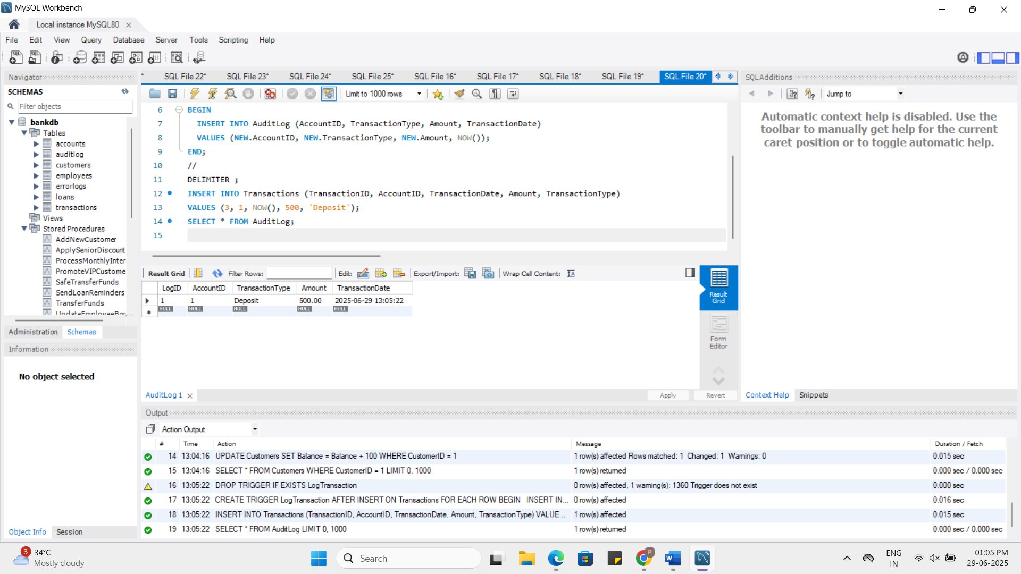

**Scenario 3:** Enforce business rules on deposits and withdrawals.

* + **Question:** Write a trigger **CheckTransactionRules** that ensures withdrawals do not exceed the balance and deposits are positive before inserting a record into the Transactions table.

**Sql:**

DROP TRIGGER IF EXISTS CheckTransactionRules;

DELIMITER //

CREATE TRIGGER CheckTransactionRules

BEFORE INSERT ON Transactions

FOR EACH ROW

BEGIN

DECLARE accBalance DECIMAL(10,2);

SELECT Balance INTO accBalance FROM Accounts WHERE AccountID = NEW.AccountID;

IF NEW.TransactionType = 'Deposit' AND NEW.Amount <= 0 THEN

SIGNAL SQLSTATE '45000'

SET MESSAGE_TEXT = 'Deposit amount must be greater than 0';

END IF;

IF NEW.TransactionType = 'Withdrawal' AND NEW.Amount > accBalance THEN

SIGNAL SQLSTATE '45000'

SET MESSAGE_TEXT = 'Insufficient balance for withdrawal';

END IF;

END;

//

DELIMITER ;

INSERT INTO Transactions (TransactionID, AccountID, TransactionDate, Amount, TransactionType)

VALUES (4, 1, NOW(), 0, 'Deposit');

INSERT INTO Transactions (TransactionID, AccountID, TransactionDate, Amount, TransactionType)

VALUES (5, 1, NOW(), 99999, 'Withdrawal');

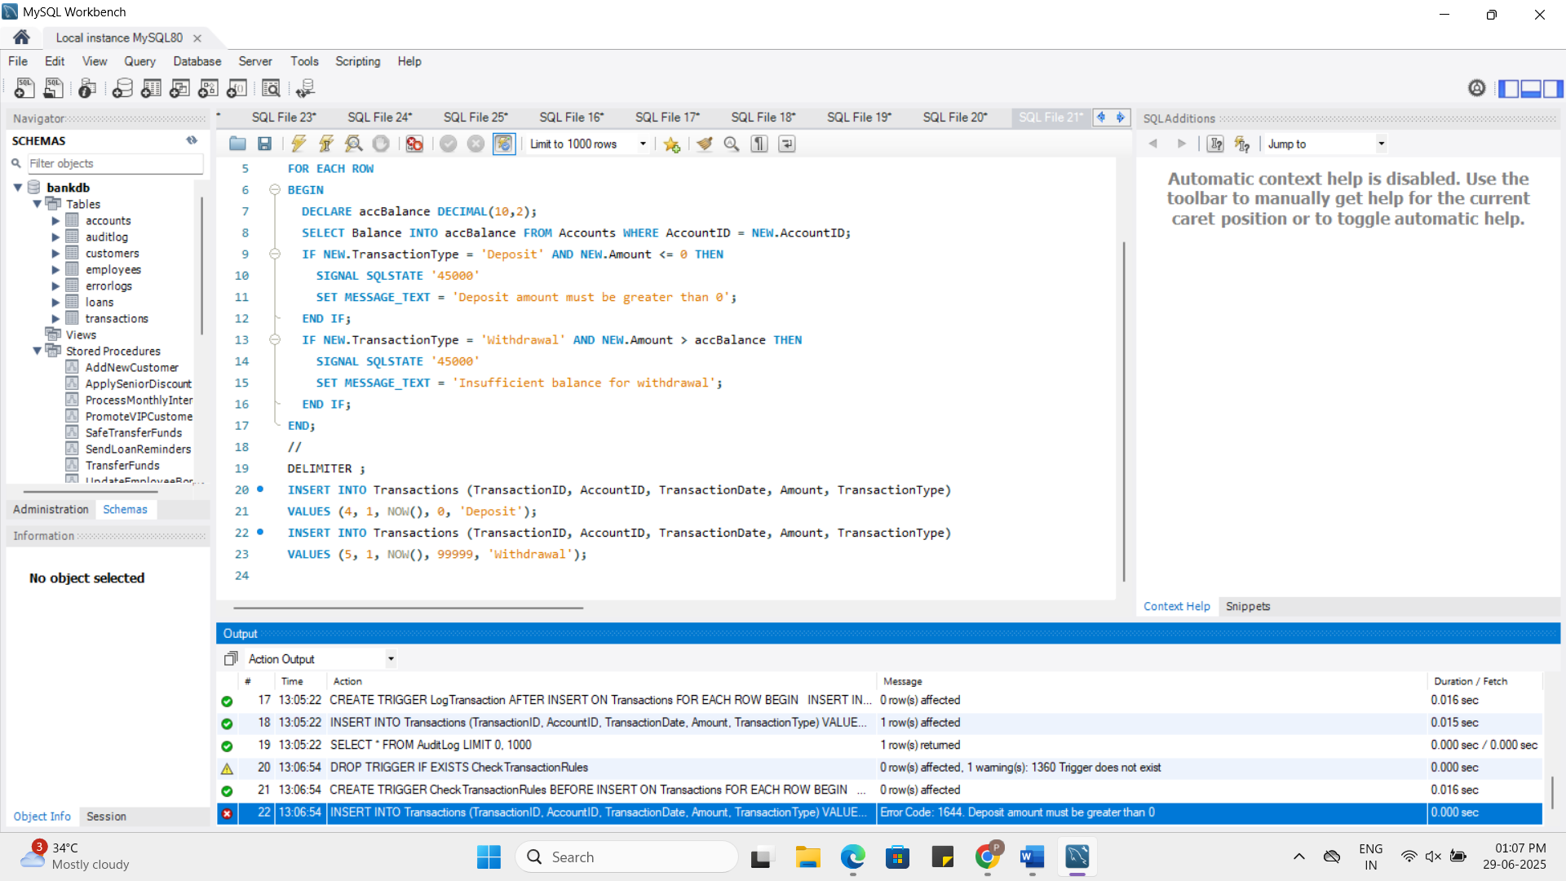

**Exercise 6: Cursors**

**Scenario 1:** Generate monthly statements for all customers.

* + **Question:** Write a PL/SQL block using an explicit cursor **GenerateMonthlyStatements** that retrieves all transactions for the current month and prints a statement for each customer.

**Sql:**

DROP PROCEDURE IF EXISTS GenerateMonthlyStatements;

DELIMITER //

CREATE PROCEDURE GenerateMonthlyStatements()

BEGIN

DECLARE done INT DEFAULT FALSE;

DECLARE c_id INT;

DECLARE t_date DATE;

DECLARE t_amount DECIMAL(10,2);

DECLARE t_type VARCHAR(10);

DECLARE cur CURSOR FOR

SELECT AccountID, TransactionDate, Amount, TransactionType

FROM Transactions

WHERE MONTH(TransactionDate) = MONTH(CURDATE()) AND YEAR(TransactionDate) = YEAR(CURDATE());

DECLARE CONTINUE HANDLER FOR NOT FOUND SET done = TRUE;

OPEN cur;

read_loop: LOOP

FETCH cur INTO c_id, t_date, t_amount, t_type;

IF done THEN

LEAVE read_loop;

END IF;

SELECT CONCAT('AccountID:', c_id, ' | Date:', t_date, ' | Type:', t_type, ' | Amount:', t_amount) AS Statement;

END LOOP;

CLOSE cur;

END;

//

DELIMITER ;

CALL GenerateMonthlyStatements();

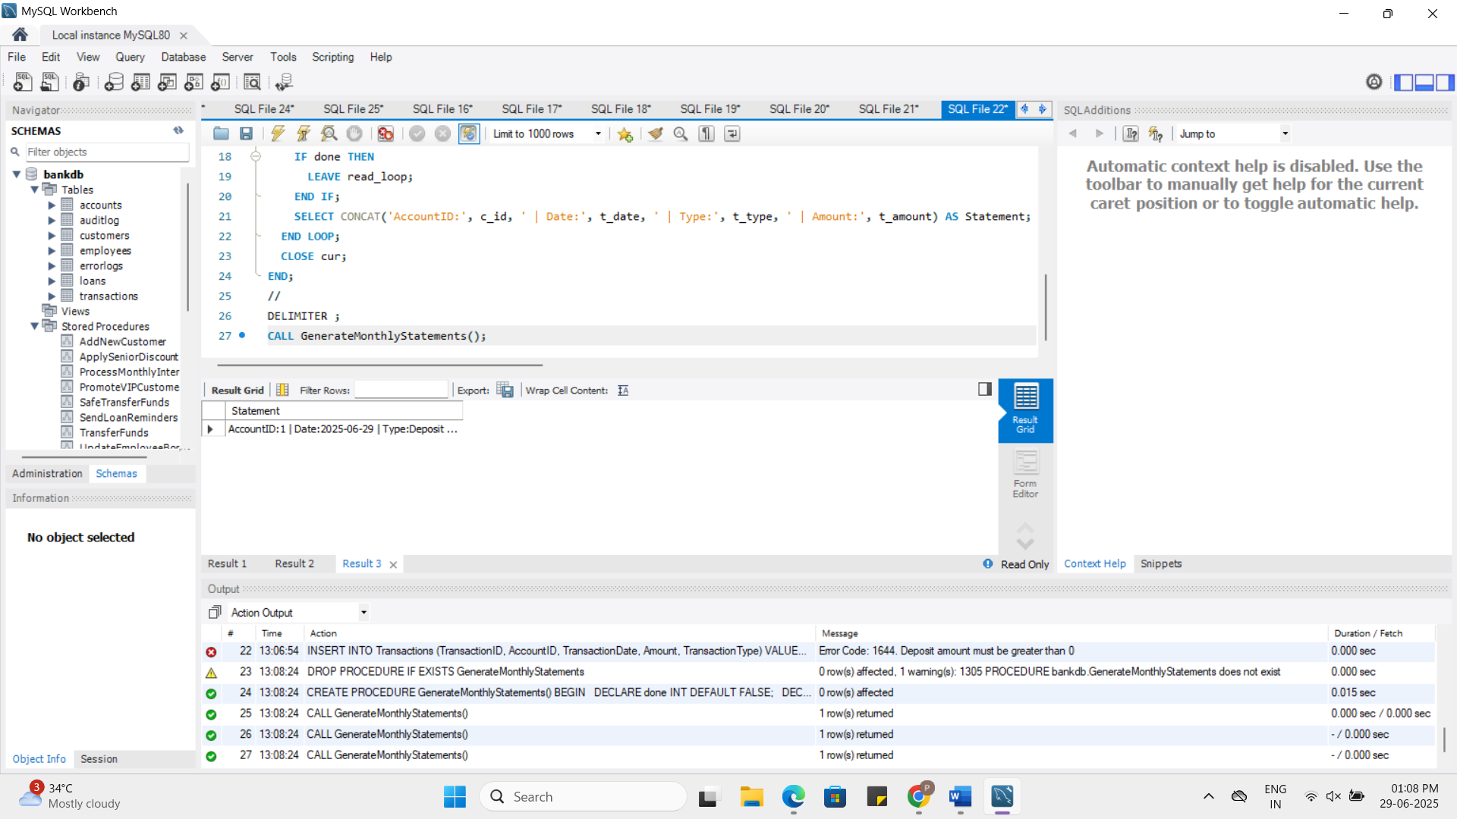

**Scenario 2:** Apply annual fee to all accounts.

* + **Question:** Write a PL/SQL block using an explicit cursor **ApplyAnnualFee** that deducts an annual maintenance fee from the balance of all accounts.

**Sql:**

DROP PROCEDURE IF EXISTS ApplyAnnualFee;

DELIMITER //

CREATE PROCEDURE ApplyAnnualFee()

BEGIN

DECLARE done INT DEFAULT FALSE;

DECLARE acc_id INT;

DECLARE cur CURSOR FOR SELECT AccountID FROM Accounts;

DECLARE CONTINUE HANDLER FOR NOT FOUND SET done = TRUE;

OPEN cur;

read_loop: LOOP

FETCH cur INTO acc_id;

IF done THEN

LEAVE read_loop;

END IF;

UPDATE Accounts

SET Balance = Balance - 100

WHERE AccountID = acc_id;

END LOOP;

CLOSE cur;

END;

//

DELIMITER ;

CALL ApplyAnnualFee();

SELECT * FROM Accounts;

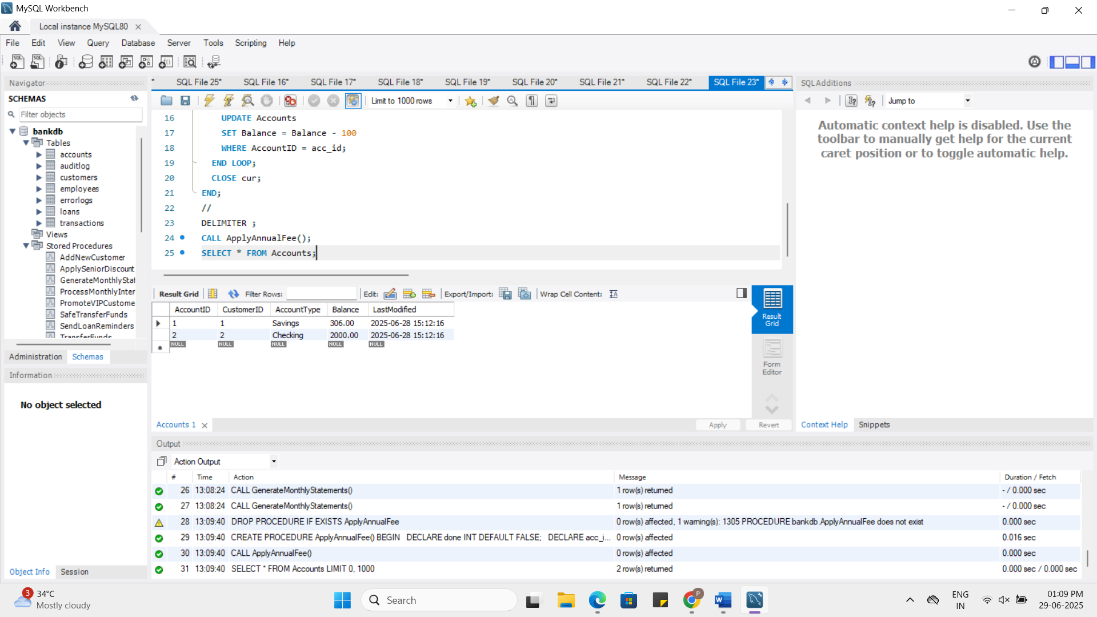

**Scenario 3:** Update the interest rate for all loans based on a new policy.

* + **Question:** Write a PL/SQL block using an explicit cursor **UpdateLoanInterestRates** that fetches all loans and updates their interest rates based on the new policy.

**Sql:**

DROP PROCEDURE IF EXISTS UpdateLoanInterestRates;

DELIMITER //

CREATE PROCEDURE UpdateLoanInterestRates()

BEGIN

DECLARE done INT DEFAULT FALSE;

DECLARE loan_id INT;

DECLARE rate DECIMAL(5,2);

DECLARE cur CURSOR FOR SELECT LoanID, InterestRate FROM Loans;

DECLARE CONTINUE HANDLER FOR NOT FOUND SET done = TRUE;

OPEN cur;

read_loop: LOOP

FETCH cur INTO loan_id, rate;

IF done THEN

LEAVE read_loop;

END IF;

UPDATE Loans

SET InterestRate = rate + 0.5

WHERE LoanID = loan_id;

END LOOP;

CLOSE cur;

END;

//

DELIMITER ;

CALL UpdateLoanInterestRates();

SELECT * FROM Loans;

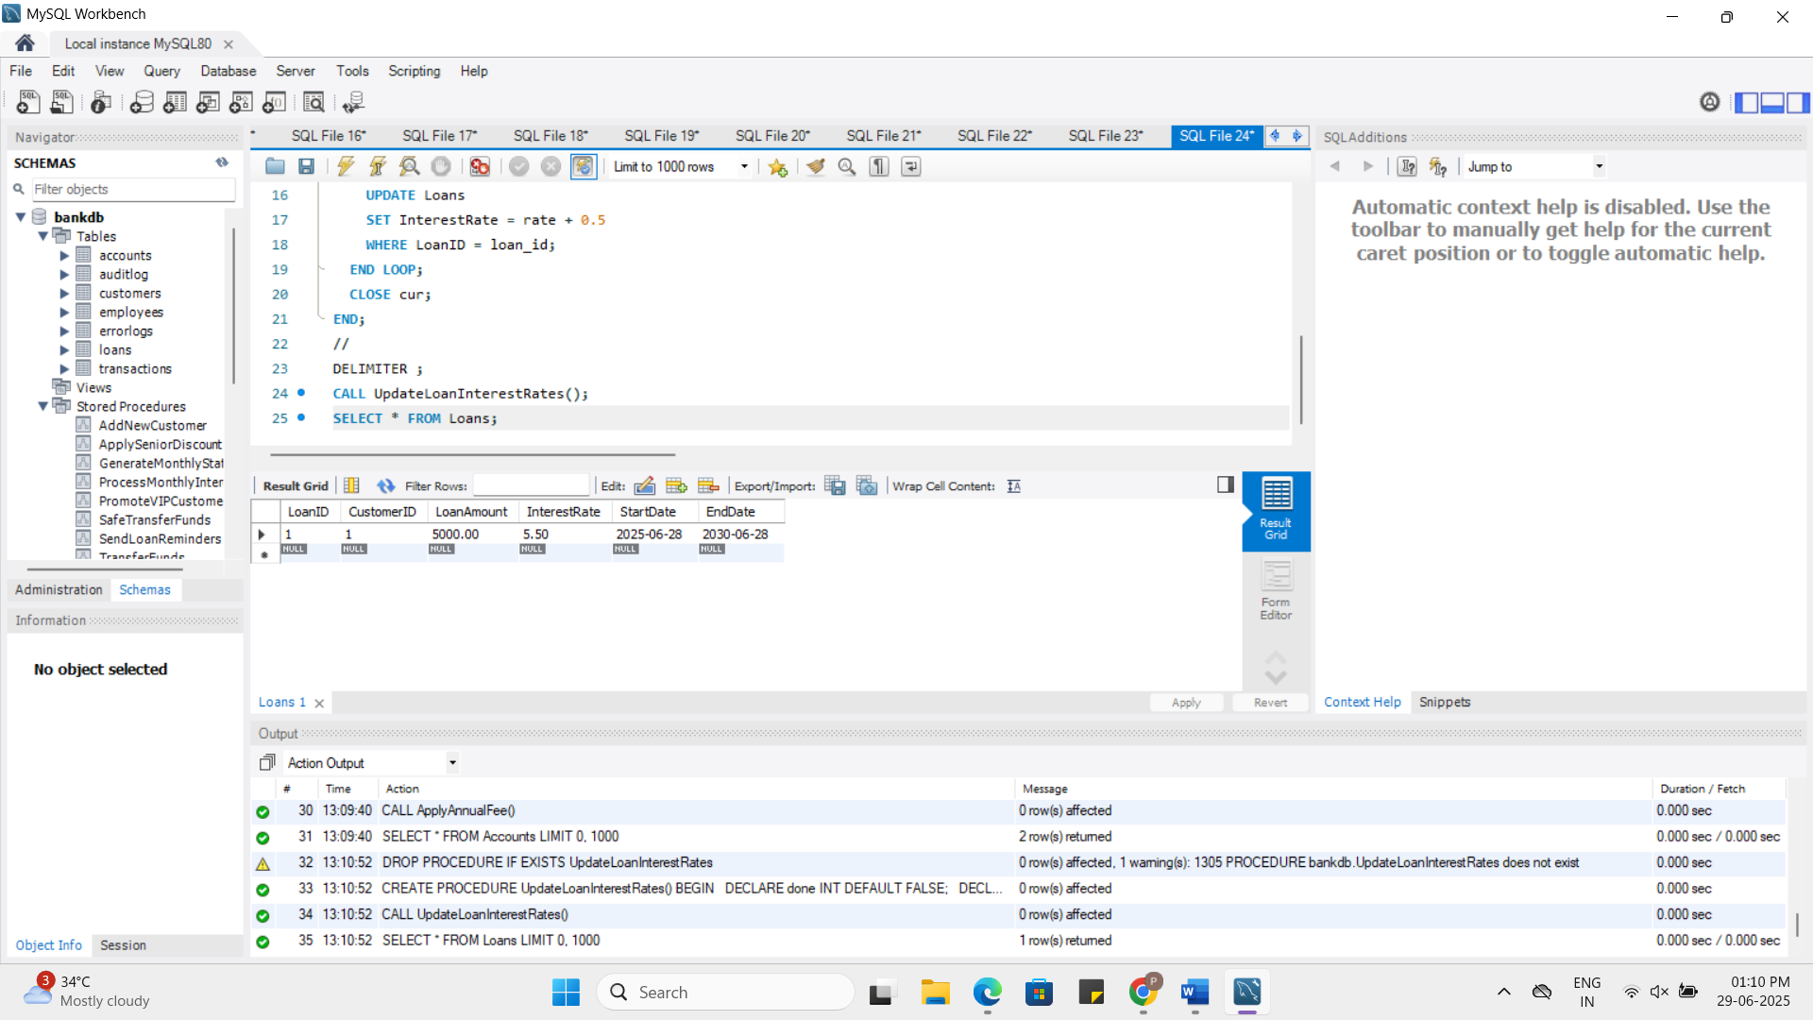

**Exercise 7: Packages**

**Scenario 1:** Group all customer-related procedures and functions into a package.

* + **Question:** Create a package **CustomerManagement** with procedures for adding a new customer, updating customer details, and a function to get customer balance.

**Answer:**

Customer Management consists of Customer’s Adding, Updating, Getting the Balance.  
 **Add of New Customer:**

DROP PROCEDURE IF EXISTS Customer_Add;

DELIMITER //

CREATE PROCEDURE Customer_Add(

IN p_CustomerID INT,

IN p_Name VARCHAR(100),

IN p_DOB DATE,

IN p_Balance DECIMAL(10,2)

)

BEGIN

INSERT INTO Customers (CustomerID, Name, DOB, Balance, LastModified)

VALUES (p_CustomerID, p_Name, p_DOB, p_Balance, NOW());

END;

//

DELIMITER ;

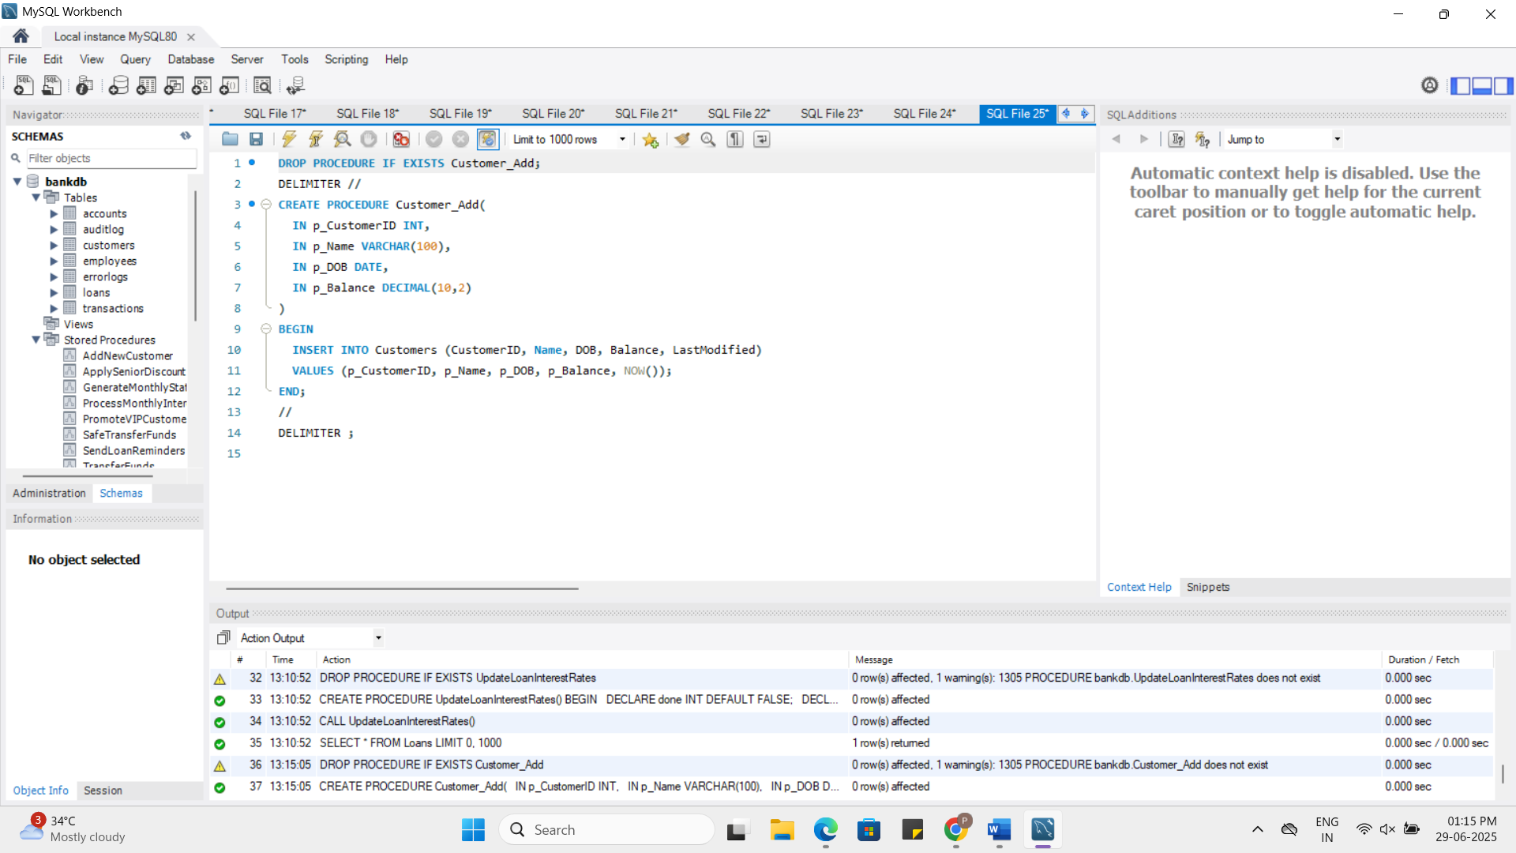

**Updating the Customers Details:**

DROP PROCEDURE IF EXISTS Customer_Update;

DELIMITER //

CREATE PROCEDURE Customer_Update(

IN p_CustomerID INT,

IN p_Name VARCHAR(100),

IN p_Balance DECIMAL(10,2)

)

BEGIN

UPDATE Customers

SET Name = p_Name,

Balance = p_Balance,

LastModified = NOW()

WHERE CustomerID = p_CustomerID;

END;

//

DELIMITER ;

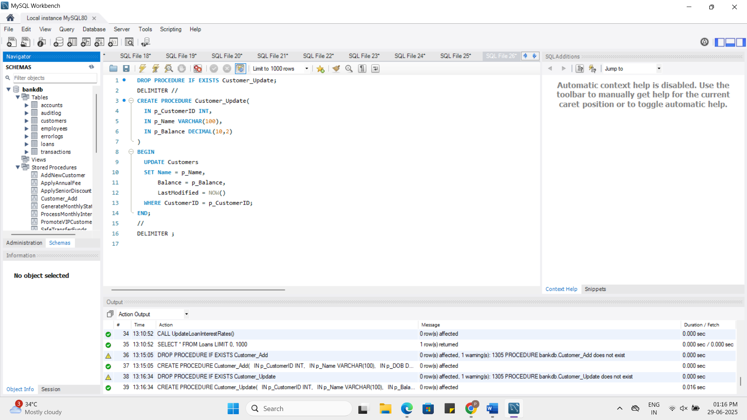

**Getting the Balance of Customer:**

DROP FUNCTION IF EXISTS Customer_GetBalance;

DELIMITER //

CREATE FUNCTION Customer_GetBalance(p_CustomerID INT)

RETURNS DECIMAL(10,2)

DETERMINISTIC

BEGIN

DECLARE bal DECIMAL(10,2);

SELECT Balance INTO bal FROM Customers WHERE CustomerID = p_CustomerID;

RETURN bal;

END;

//

DELIMITER ;

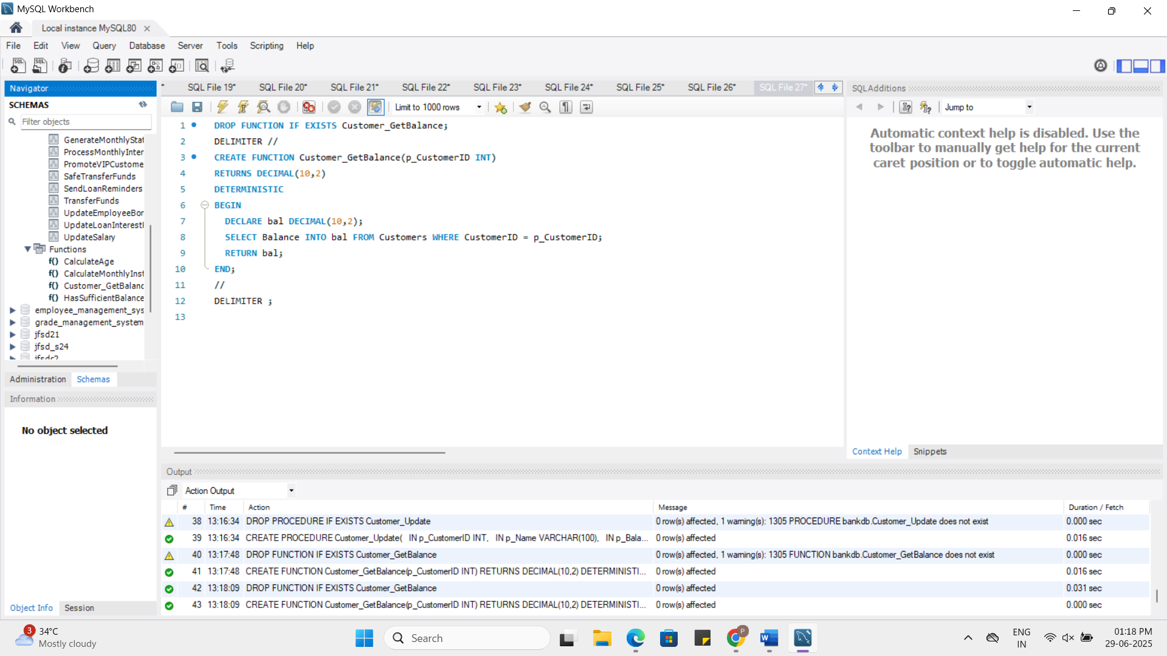

**Scenario 2:** Create a package to manage employee data.

* + **Question:** Write a package **EmployeeManagement** with procedures to hire new employees, update employee details, and a function to calculate annual salary.

**Answer:**

Employee Management consists of Hiring, Updating, Annual Salary

**Hiring new employees:**

DROP PROCEDURE IF EXISTS Employee_Hire;

DELIMITER //

CREATE PROCEDURE Employee_Hire(

IN p_EmpID INT,

IN p_Name VARCHAR(100),

IN p_Position VARCHAR(50),

IN p_Salary DECIMAL(10,2),

IN p_Department VARCHAR(50),

IN p_HireDate DATE

)

BEGIN

INSERT INTO Employees (EmployeeID, Name, Position, Salary, Department, HireDate)

VALUES (p_EmpID, p_Name, p_Position, p_Salary, p_Department, p_HireDate);

END;

//

DELIMITER ;

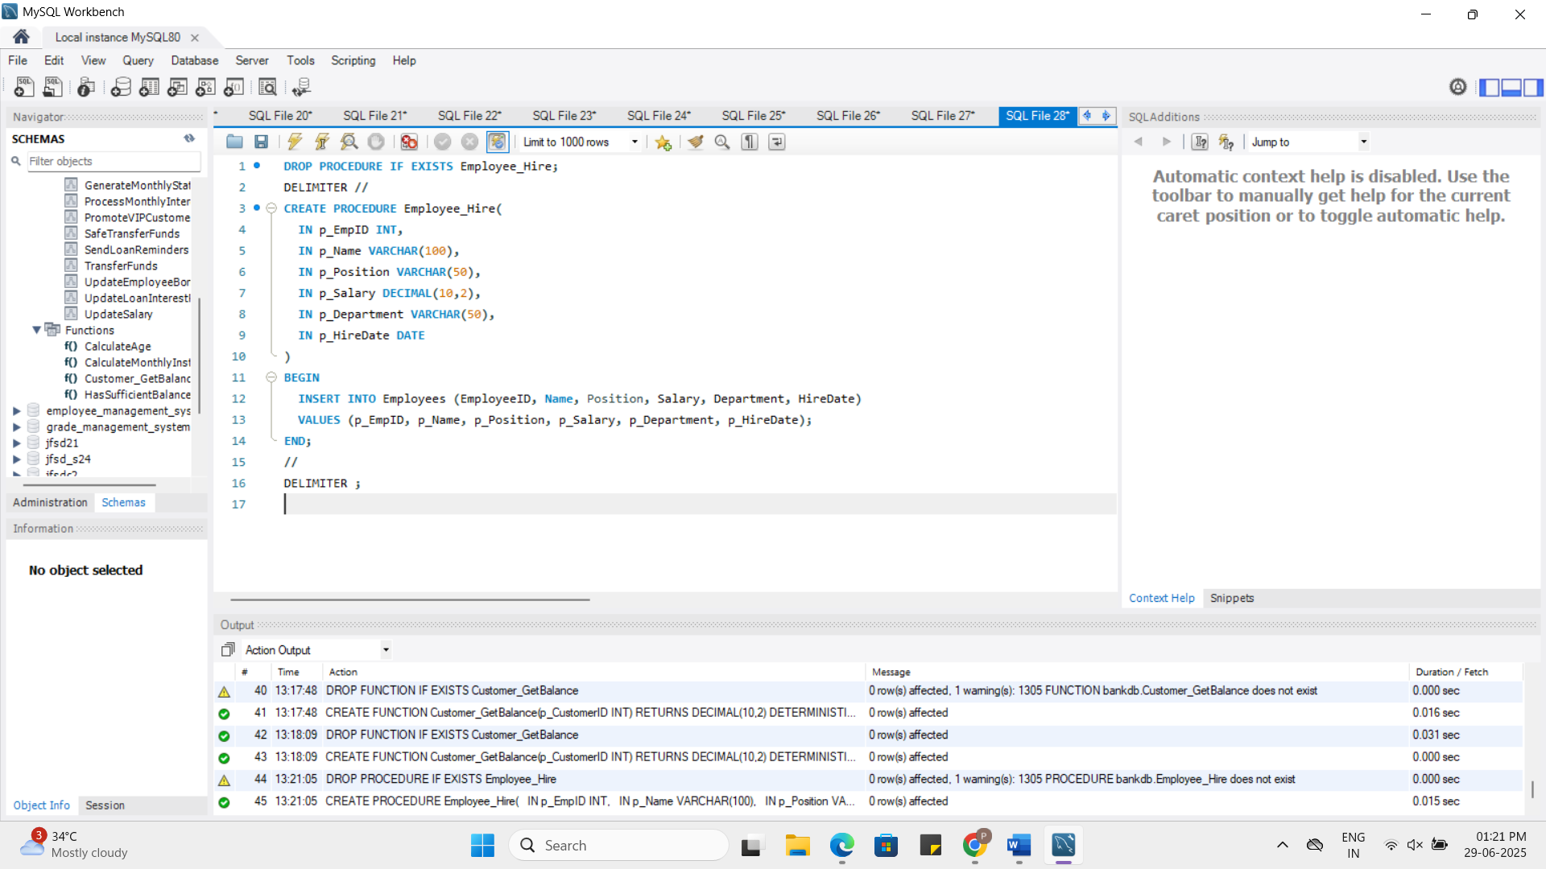

**Updating Employees Details:**

DROP PROCEDURE IF EXISTS Employee_Update;

DELIMITER //

CREATE PROCEDURE Employee_Update(

IN p_EmpID INT,

IN p_Position VARCHAR(50),

IN p_Salary DECIMAL(10,2)

)

BEGIN

UPDATE Employees

SET Position = p_Position, Salary = p_Salary

WHERE EmployeeID = p_EmpID;

END;

//

DELIMITER ;

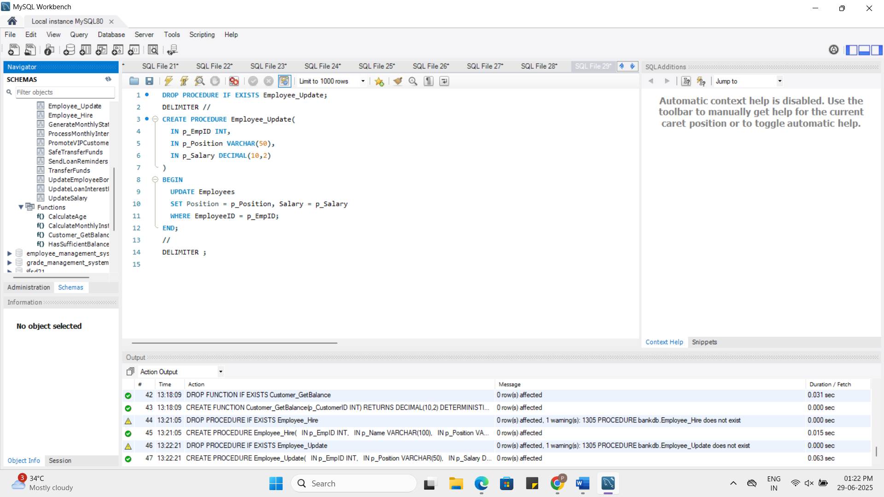

**Annual Salary of Employee:**

DROP FUNCTION IF EXISTS Employee_AnnualSalary;

DELIMITER //

CREATE FUNCTION Employee_AnnualSalary(p_EmpID INT)

RETURNS DECIMAL(10,2)

DETERMINISTIC

BEGIN

DECLARE sal DECIMAL(10,2);

SELECT Salary * 12 INTO sal FROM Employees WHERE EmployeeID = p_EmpID;

RETURN sal;

END;

//

DELIMITER ;

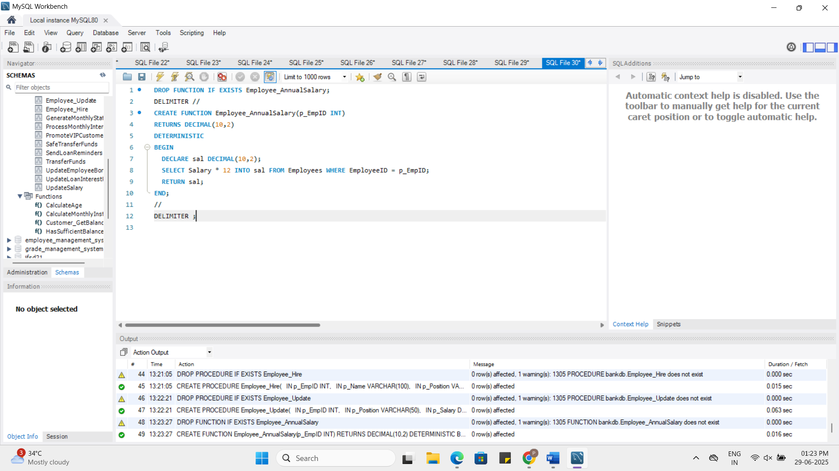

**Scenario 3:** Group all account-related operations into a package.

* + **Question:** Create a package **AccountOperations** with procedures for opening a new account, closing an account, and a function to get the total balance of a customer across all accounts.

**Answer:**

Account Operations consist of opening the account, closing the account, viewing the total balance of the account by the customer

**Opening of the account:**

DROP PROCEDURE IF EXISTS Account_Open;

DELIMITER //

CREATE PROCEDURE Account_Open(

IN p_AccountID INT,

IN p_CustomerID INT,

IN p_AccountType VARCHAR(20),

IN p_Balance DECIMAL(10,2)

)

BEGIN

INSERT INTO Accounts (AccountID, CustomerID, AccountType, Balance, LastModified)

VALUES (p_AccountID, p_CustomerID, p_AccountType, p_Balance, NOW());

END;

//

DELIMITER ;

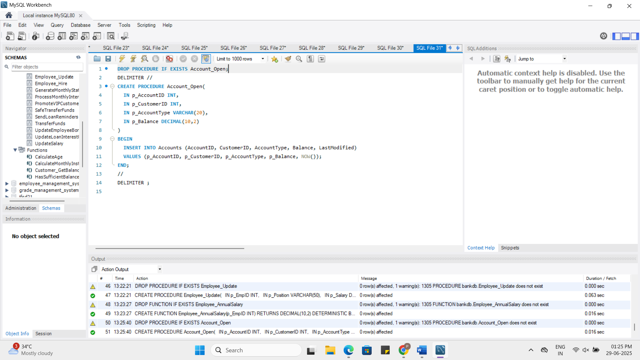

**Total Balance of the account:**

DROP FUNCTION IF EXISTS Account_TotalBalanceByCustomer;

DELIMITER //

CREATE FUNCTION Account_TotalBalanceByCustomer(p_CustomerID INT)

RETURNS DECIMAL(10,2)

DETERMINISTIC

BEGIN

DECLARE total DECIMAL(10,2);

SELECT SUM(Balance) INTO total FROM Accounts WHERE CustomerID = p_CustomerID;

RETURN total;

END;

//

DELIMITER ;

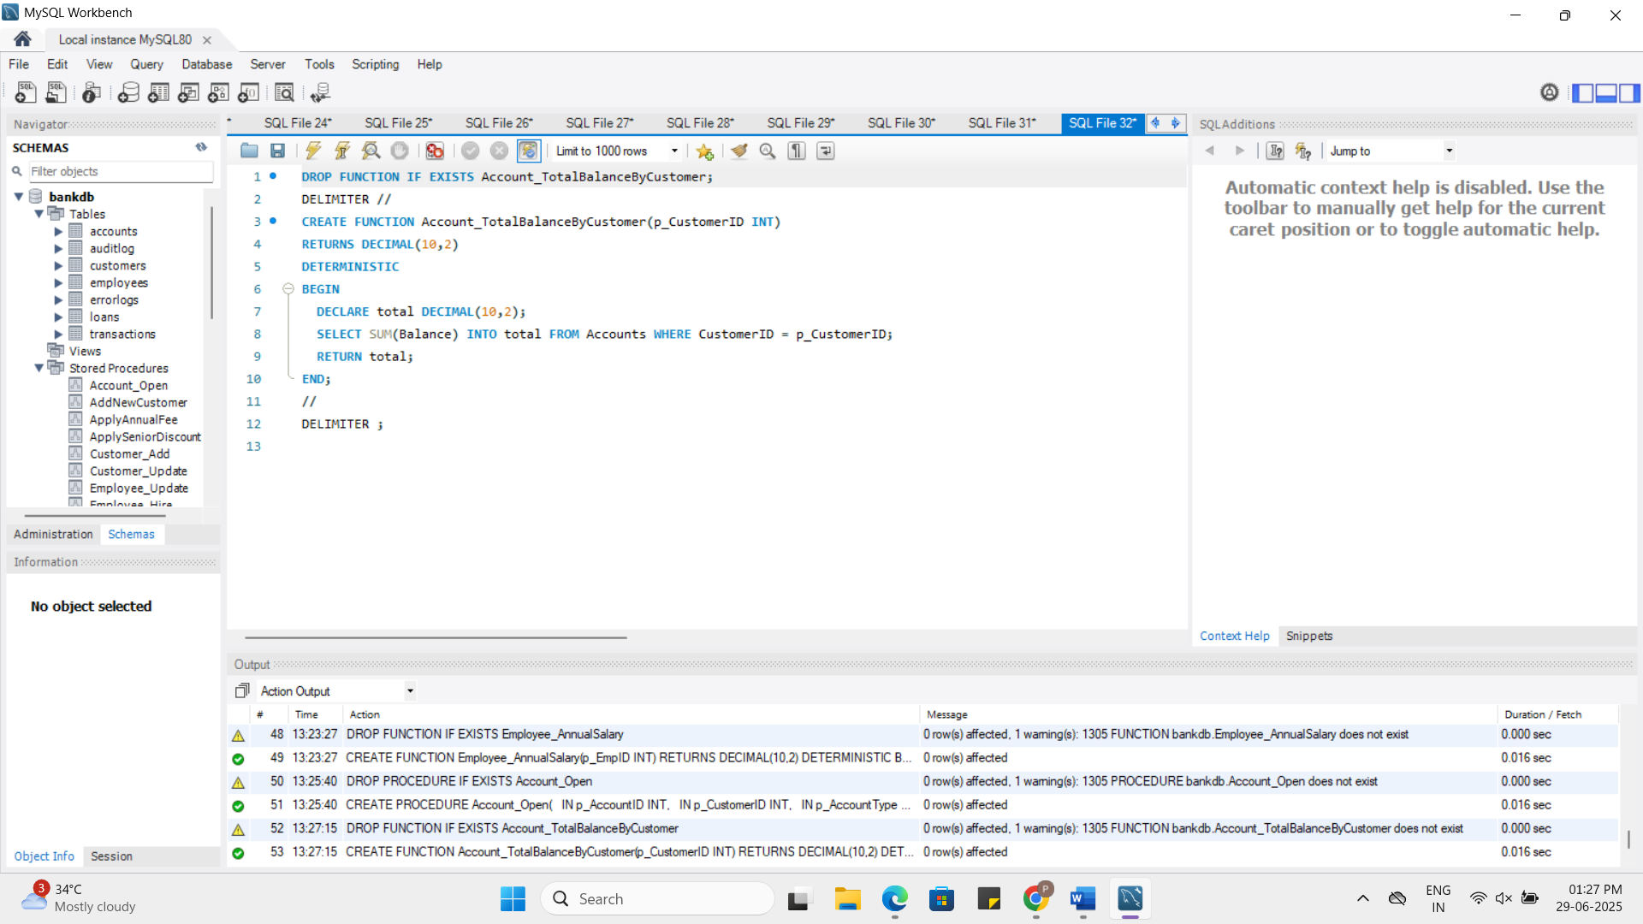

**Closing of the account:**

DROP PROCEDURE IF EXISTS Account_Close;

DELIMITER //

CREATE PROCEDURE Account_Close(

IN p_AccountID INT

)

BEGIN

DELETE FROM Accounts WHERE AccountID = p_AccountID;

END;

//

DELIMITER ;

